Josephene (Jellison) Ashley
December 2, 1852 – 1940

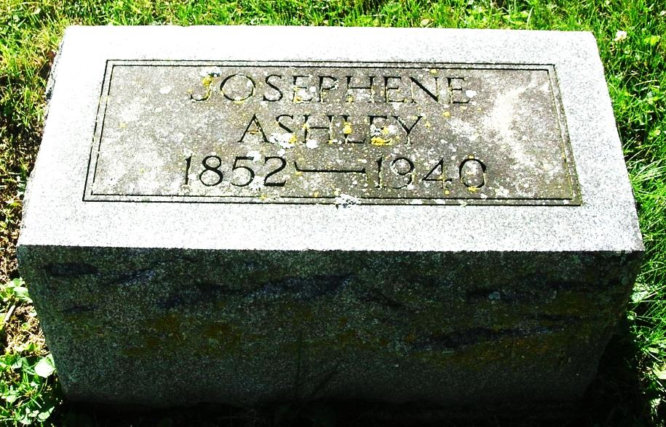

MRS JOSEPHINE ASHLEY IS DEAD
Jay County Native Was 87 Years Old
Funeral To Be Saturday.

Josephine Ashley, 87, lifelong resident of Jay county, died Thursday night at 11:55 o'clock at her West Third street home following a nine-weeks' illness of paralysis. Her condition became serious one week ago. Mrs. Ashley was born December 2, 1852, in Jay county the only daughter of Ruben and Maria (Bickel) Jellison. Her first marriage was December 19, 1869, to George B. Ware, who died July 22, 1874. On October 9, 1875, she was married to A. J. Ashley who died January 17, 1927. Surviving are five children; Arthur of Portland; Mrs. Anna, wife of B.A. Underwood of Jackson, Mich.; Mrs. Goldie, wife of Elmer Heniser of near Portland; Miss Flora Ware at home and John Ware of Milwaukee, Wis.; ten grandchildren and eight great grandchildren. One daughter is deceased. Funeral services will be held Saturday afternoon at 2 o'clock from the Portland United Brethren church in charge of the pastor, Rev. J.H. Nall. Burial will be made in the Lower Salamonie cemetery. The body was removed to the Williamson and Sons funeral home where it will remain until one o'clock Saturday afternoon when it will be taken to the church for one hour before the services. The casket will be closed during the service.

Newspaper clipping with handwritten date of April, 1940

Contributed by David Kennedy

