Elizabeth (Bubp) Brosher
February 7, 1814 – March 8, 1894

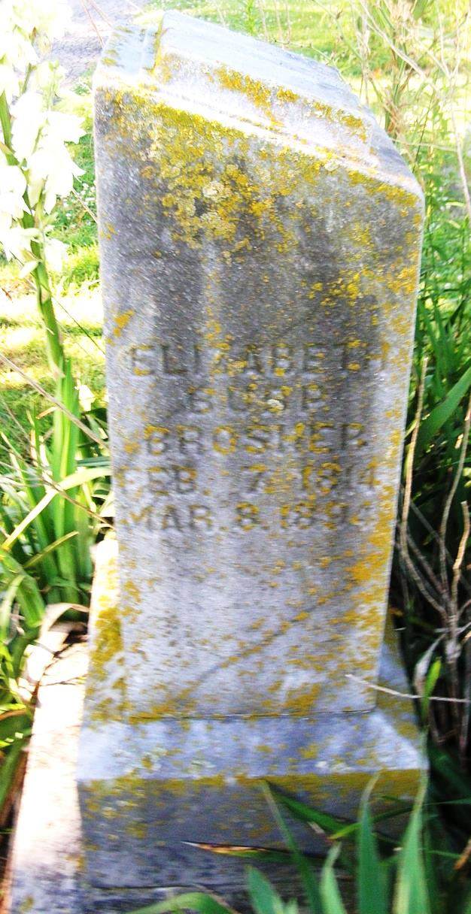
Elizabeth Bubp Brosher was born February 7, 1814 and died March 8, 1894, aged 80 years, 1 month and 1 day. She was married to Peter Brosher August 25, 1838 and to this union were born eleven children, two girls and nine boys. Five of the children have preceded her to the spirit world. She leaves a husband, six children and many friends to mourn, but their loss is her gain. She was born in New Cumberland County, Pennsylvania and moved to Ohio in May, 1838 and from there to Iowa in 1856, and then moved back to Ohio in 1899 and then they moved to Indiana in 1879.
Portland Daily Commercial, Jay County, IN; March 15, 1894
Contributed by Jim Cox

