Esther Victoria (Walker) Burkey
Aril 29, 1920 - April 29, 2006

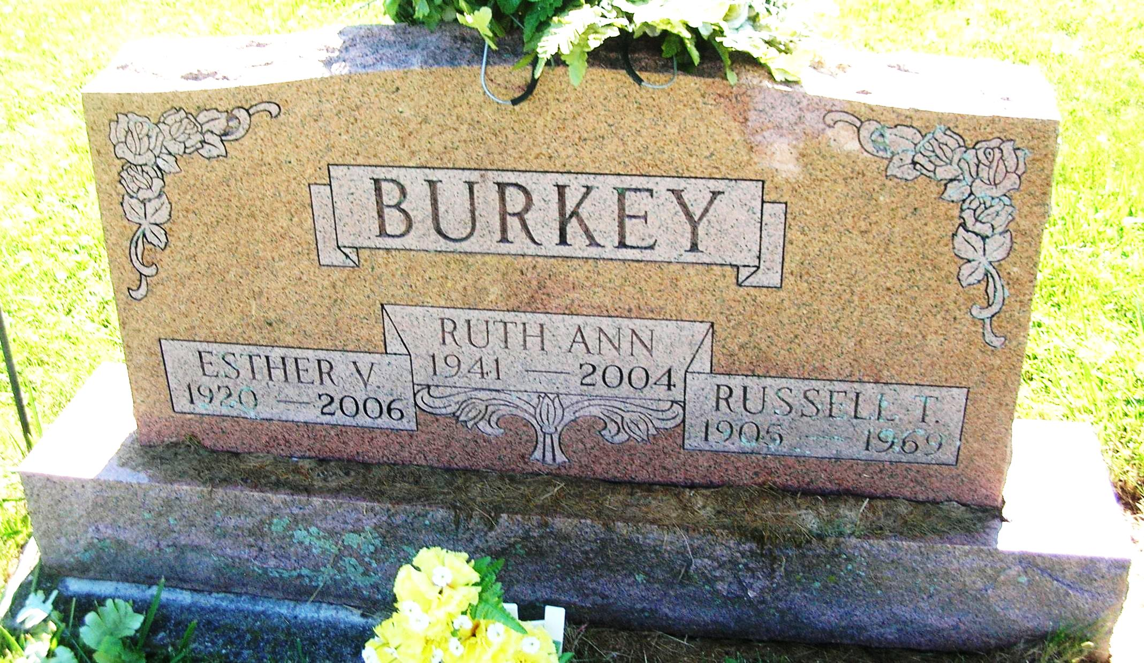

Esther Victoria Burkey, 86, 721 E. High St., Portland, died Saturday at her home.
Born in Pennville on April 29, 1920, to Linnie W. and Ida Mae (Lanning) Walker, she married Russel T. Burkey on Jan. 3, 1940. He died on April 10, 1969.
She had worked at Beals Restaurant in Portland.
Survivors include four sons, James R. Burkey and Daniel Burkey, both of Portland, Larry W. Burkey, Ballston Spa, N.Y., and Robert T. Burkey, Ridgeville; two brothers, William Robert Walker and Fredrick L. Walker, both of Portland; five sisters, Margaret Smith, Celina, Ohio, Mabel Holcomb, Jean Balle, and Barbara Burkett, all of Portland, and Patricia Miller, Windfall; six grandchildren and several great-grandchildren.
Services are Tuesday at 10 a.m. in the Baird-Freeman Funeral Home with Pastor Randy Smith officiating. Burial will be in the Little Salamonia Cemetery.
Visitation is today from 5 to 8 p.m. at the funeral home.
Memorials may be sent to the Jay County Humane Society.

Commercial Review, The (Portland, IN) - Tuesday, May 2, 2006
Contributed by Jane Edson

