Frank Burkey
1904 – January 30, 1993

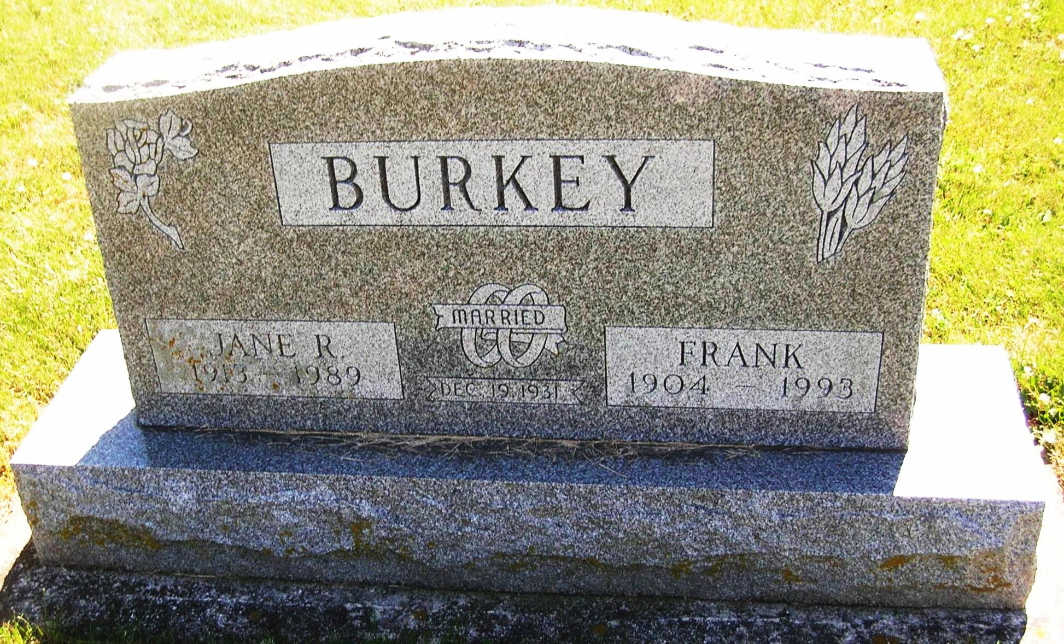
Services for Frank Burkey, 88, a resident of Portland Community Care Center West for the past three years, will be held at 11 am Wednesday in the Portland Chapel of the Williamson and Spencer Funeral Home with the Rev. H. R. Burkett officiating. Burial will be in the Little Salamonia Cemetery, southeast of Portland. A former resident of RR 3, Portland, Burkey died Saturday evening at the center following an extended illness.
Portland Commercial Review, Jay County, IN; Tuesday, February 2, 1993
Contributed by Jim Cox

