Charles W. Caster
1918-2006

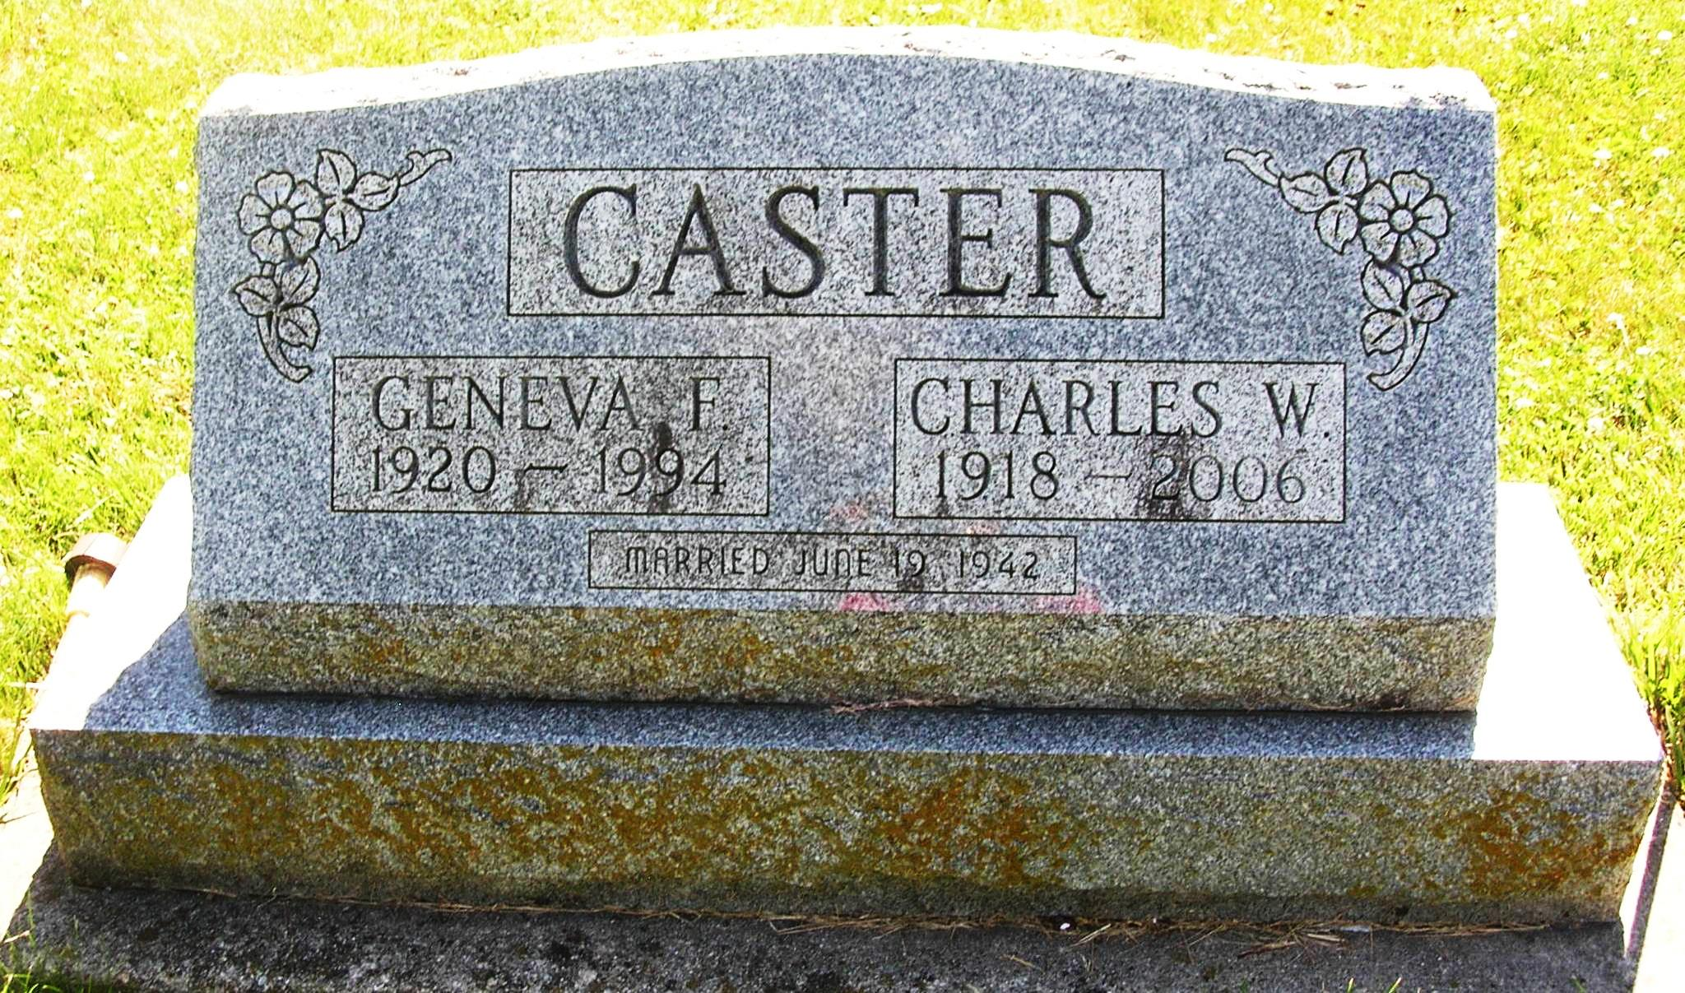

The following obituary is being republished to provide additional information given to The Commercial Review.
Charles W. Caster, 87, 105 E. Elder Street, Portland, died Wednesday at Ball Memorial Hospital, Muncie.
Born in Portland on July 27, 1918, to Charles E. and Mary (Cummins) Caster, he married Geneva F. Duvall on June 19, 1942. She died on May 27, 1994.
An Army Airforce veteran of World War II, he was the service manager for Maitlen Motors in Portland. Memberships include the Portland Moose Lodge and Jay County Conservation Club.
Survivors include three sons, Ted, Jim and Chuck Caster, all of Portland; a daughter, Mrs. Melvin (Wanda) Sanders, Portland; and four grandchildren.
Services are Saturday at 10 a.m. in the Baird-Freeman Funeral Home with Pastor Mark Strietelmeier officiating. Visitation is Friday from 3 to 7 p.m. in the funeral home.
Memorials may be sent to the Leukemia Foundation.

Commercial Review, The (Portland, IN) - Saturday, March 25, 2006
Contributed by Jane Edson

