Jason W. Cook
May 12, 1821 – July 18, 1893

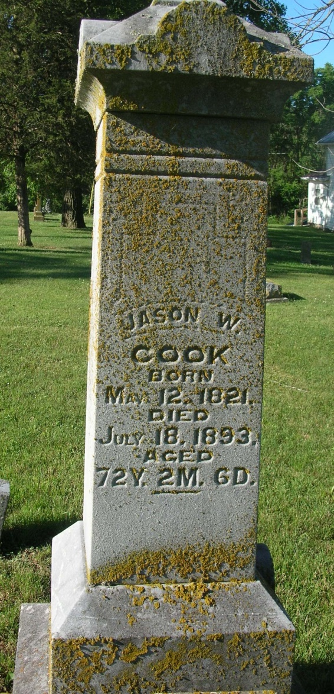
Jason Cook, an old esteemed citizen, residing two and one-half miles southeast of Portland, was fatally injured Monday evening and his death occurred Tuesday night at 11 o’clock. Mr. Cook went to the barn in the evening as was his habit and opened the door to let his horses in. The animals were out in the pasture and came to the barn on a gallop, knocking Mr. Cook down and trampling over his prostrate body. He was standing in the barn door but did not have time to get out of the way of the horse. The funeral services will be held today at the Salamonia Christian Church.
Portland Weekly Commercial, Jay County, IN; September 14, 1893
Contributed by Jim Cox

