Betty Ilene (Stahl) Coy
February 26, 1941 – January 19, 2009

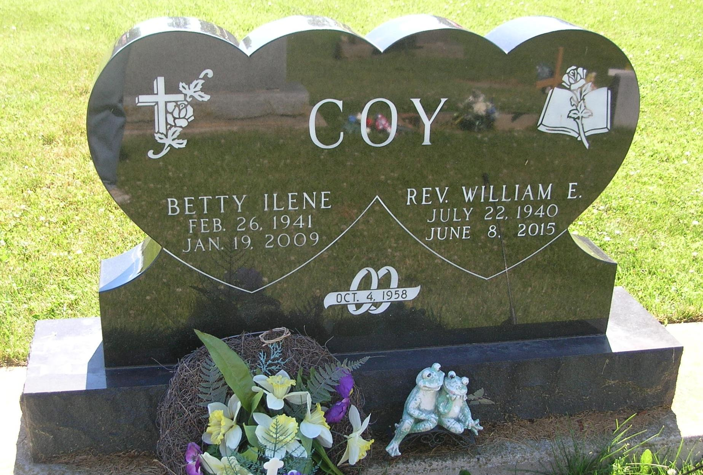

Betty I. Coy, age 67, 720 West Walnut Street, Portland passed away Monday morning [1/19/2009] in the Jay County Hospital following a sudden illness. She was born in Portland February 26, 1941, the daughter of Ed and Myrtle (Hines) Stahl. She was married October 4, 1958 to William E. Coy who survives. She worked for Jay County Head Start and had been employed at Hardees. She was an Elder, Deacon, Sunday School Teacher, Organist, and Secretery/Treasurer of Little Salamonia Church. She was also a member of Aglow. Surviving are her husband William, One son William E. Coy Jr. of Portland, Three daughters Kathy Fitzgerald of Fulton / Owentown, Kentucky, Nancy Crites of Indianapolis and Linda Goldacker of Perrysburg, Ohio, One brother Robert Stahl of Americus, Georgia, Two sisters Sivilla Watson of Tampa, Florida and Dorothy Bechtol of Omaha, Nebraska Sixteen grandchildren and fourteen great grandchildren She was preceded in death by a sister Jean Stillwell and grandson Jacob Heath Caylor. Funeral services will be Thursday at 10:00 A.M. in the Bair-Freeman Funeral Home with Pastor Esther Kershaw presiding. Burial will be in the Little Salamonia Cemetery. Visitation will be Wednesday from 4:00 – 8:00 P.M. Memorials can be [cut off]
Contributed by Joan Shoffner – no source listed

