Susie (Evans) Denniston
December 24, 1872 – January 30, 1918

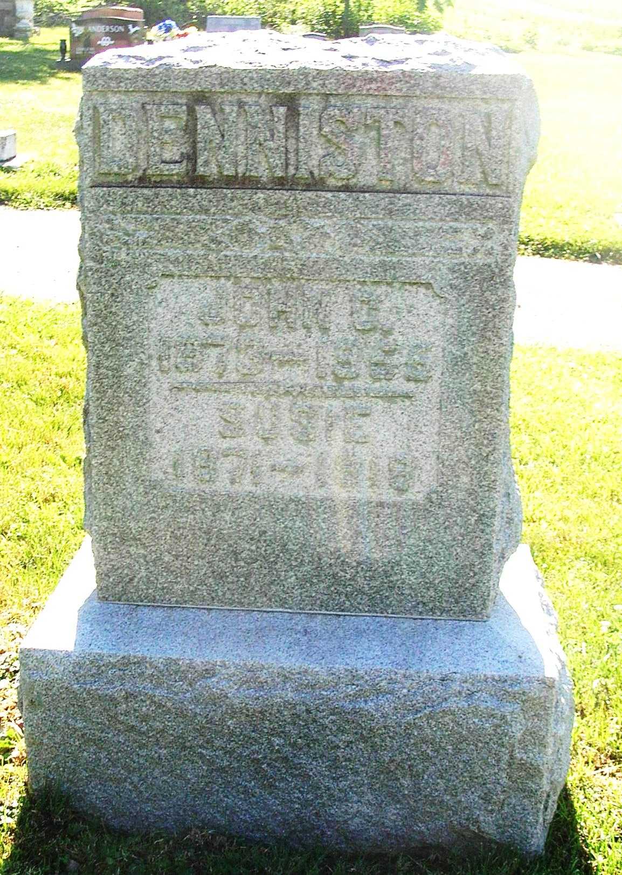

MRS. DENNISTON PASSES AWAY WEDNESDAY EVE
Dies at her late home after illness of Tuberculosis

Susie Denniston, wife of John C. Denniston, died Wednesday evening at 5 o'clock at her home four miles southwest of here, after an illness of tuberculosis. The deceased was the daughter of St. Clair and Lydia Evans and was born in Fleming County, Kentucky, December 24th, 1871, being at the time of her death 46 years, one month and six days of age. She leaves to mourn her loss, three children, Hazel, Alleen and Harry, at home. Two sons preceded her in death. One sister, Lulu, wife of Albert Nicholson, of Cincinnati, and three brothers, Albert and Daugherty Evans of Lexington, KY; John Evans of Hamilton, Ohio, also survive. Two brothers preceded her in death. Funeral services will be held from the Salamonia Church Friday afternoon at 2:30, Rev. Judy officiating. Interment will be made at the Salamonia cemetery.

DENNISTON FUNERAL

Mrs. Albert Nicholson of Cincinnati, Mrs. Mary Durbin, and Mrs John Slaughter and John Evans of Hamilton, Ohio, Henry Denniston and B. Evans of Ohio, and Albert Evans of Lexington, KY., returned to their homes Saturday after attending the funeral services of the late Mrs. John Denniston, south of here, which were held Friday afternoon at 2 o'clock from the Salamonia church, Rev. Judy in charge. Interment was made at Salamonia cemetery.

Portland Commercial Review, Jay County, IN; Thursday Jan 31st, 1918
*****
Mrs. Susie Evans Denniston, daughter of St. Clair and Lydia Evans was born in Fleming County, KY., Dec. 24, 1871, and departed this life at her home near Portland, Jay county, Indiana, Jan 30, 1918, aged 46 years, one month and six days. October 10, 1895, she was united in marriage to John C. Denniston. Four children blessed this union, one of whom, Willie Arvel, died in infancy. Sister Denniston was converted after her marriage and united with the Baptists In a country church near Lexington, KY. Moving to Jay county, Indiana, and locating near Portland, she, with her husband united with the Salamonia Christian Church some eight years ago. Because of failing health she was not able to attend the services of the church but was a home department member of the Sunday school and was faithful to her profession. She died in the triumph of her faith in Jesus the Great Head of the Church. A faithful servant of the Master she has been called to her reward. A loving wife and mother, a kind and obliging neighbor and an every day follower of Christ, she will be missed at home, in the neighborhood, and by her church. Leaving all to Him who knoweth, let us cherish her memory and emulate her virtues. Those who mourn are her sorrowing husband and two daughters, Hazel P. and Aleen M. and one son, Harry E.; three brothers, Albert and Daugherty of Lexington, KY., and John of Hamilton, Ohio, and one sister, Mrs. Lulu Nicholson of Cincinnati, Ohio, with other relatives and a host of friends in both Indiana and Kentucky. Funeral was held from the Salamonia Christian church Friday, Feb. 1, 1918 at 2:30 p.m. conducted by her pastor; sermon from the text I. Cor. 15:6; theme, "Fallen Asleep" . Interment in the church yard cemetery.

CARD OF THANKS. For the help, kindness and sympathy of our neighbors and friends in our deep sorrow we are truly thankful.
JOHN C. DENNISTON and FAMILY.

Portland Commercial Review; Monday Feb 4th, 1918

All contributed by Lakegirl!

