Deta F. Gillespie

March 28, 1918 - Nov. 16, 2007

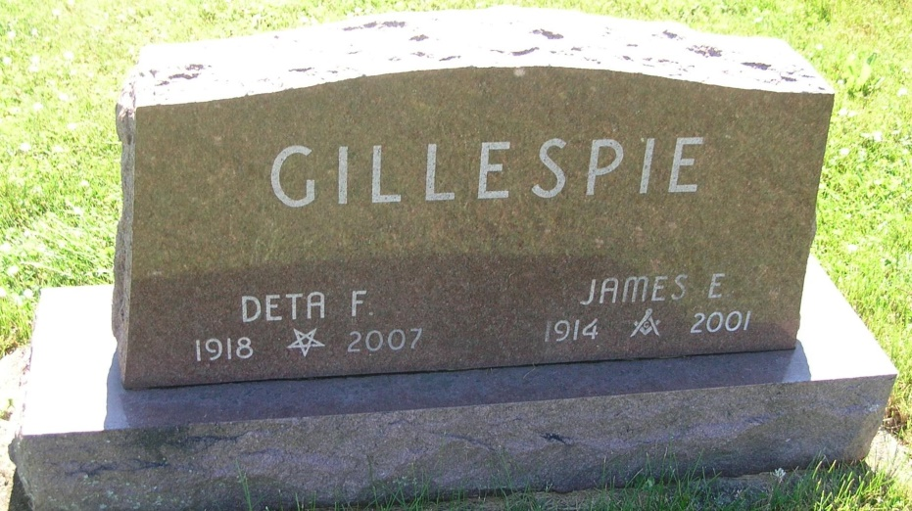

Deta F. Gillespie, 89 passed away Friday, Nov. 16, 2007 in the Miller's Merry Manor in Middletown after a brief illness.
She was born March 28, 1918 in Pike Twp. Jay County, the daughter of Thomas Franklin and Martha Ann (Wiggs) Corle. She attended school in Madison Twp., Jay County. She was married March 27, 1937 to James E. Gillespie of Bryant and he passed away Oct. 30, 2001.
She was a housewife and member of Zion Lutheran Church where she was a member of the choir and several women's groups. She was also a member of the Jay County Women's Chorus. She was a 50 year member of the Order of the Eastern Star and the White Shrine.
Survivors include, three children, Lewis Gillespie (Kay), Muncie, Cynthia Iliff, Columbus, Ohio, Jan Gillespie (Nancy), Upland; brother, Hascal Corle, Berne; grandchildren, Chris (Tina) Sanders, Hartford City, Jason (Deanna) Sanders, Columbus, Ohio, Brennan (Ashley) Gillespie, Muncie, Shannon (Jane) Gillespie, Crawfordsville, Heather Gillespie, Sarasota, Fla., and Lisa Gillespie, Lexington, Ky.; nine great-grandchildren; several nieces and nephews.
She was preceded in death by her husband, James, two sisters, six brothers.
Private funeral services and burial will be held. Internment will be in the Little Salamonia Cemetery, Portland.
Memorials may be made to Zion Lutheran Church, 218 East High Street, Portland, IN 47371 or an Alzheimer's organization.
Baird-Freeman Funeral Home, 221 N. Meridian, Portland, Ind. handled arrangements.

Chronicle-Tribune (Marion, IN) - Saturday, November 17, 2007
Contributed by Jane Edson

