George F. Harris
June 6, 1911 – December 1, 1989

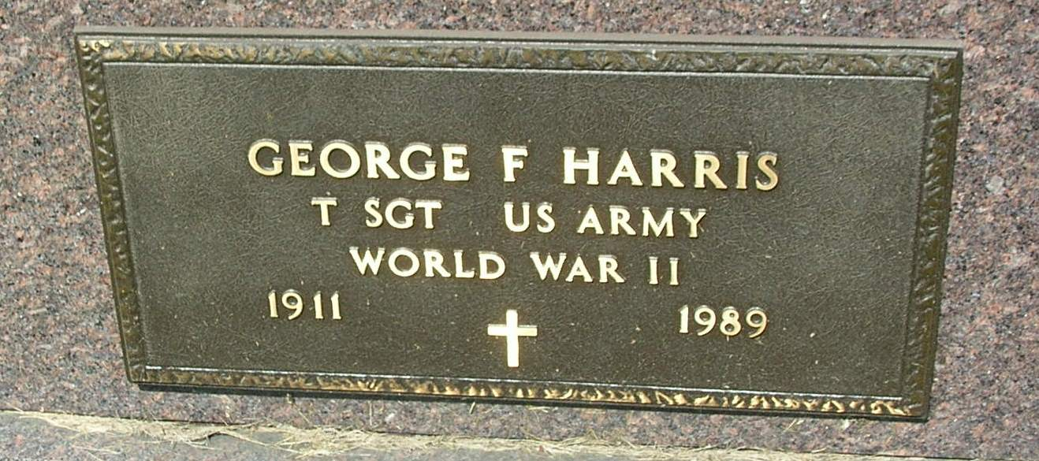
George F. Harris, 78, 117 Bittersweet Lane, Portland, died Friday afternoon at Jay County Hospital. The son of Cornelius and Emma (Hendrickson) Harris, he was born on June 6, 1911 in Randolph County. He was married in 1932 to Octavia Hardy, who survives.
An Army veteran of World War II, he was employed at Implement Sales and Service and at Maitlen Motors in Portland as a salesman before his retirement. He was a member of American Legion Post No. 211 and Eagles Lodge No. 928, both of Portland.
Surviving in addition to his wife are three sisters, Eva Bosworth and Florence Haworth, both of Winchester, and Irene Weimer, Farmland; and several nieces and nephews.
Services will be at 2 p.m. Monday at the Baird-Freeman Funeral Home, Portland, with Rev. Mark Strietelmeier officiating. Burial will be in Little Salamonia Cemetery, southeast of Portland. Military graveside services will be conducted by American Legion Post No. 211. Friends may call at the funeral home from 2 to 9 p.m. Sunday. Memorials may be made to the Jay County Heart Fund or ro the charity of the donor's choice.
Portland Commercial Review, Jay County, IN; December 2, 1989
Contributed by Dave D

