Gladys A. Harshman
1899 – May 20, 1999

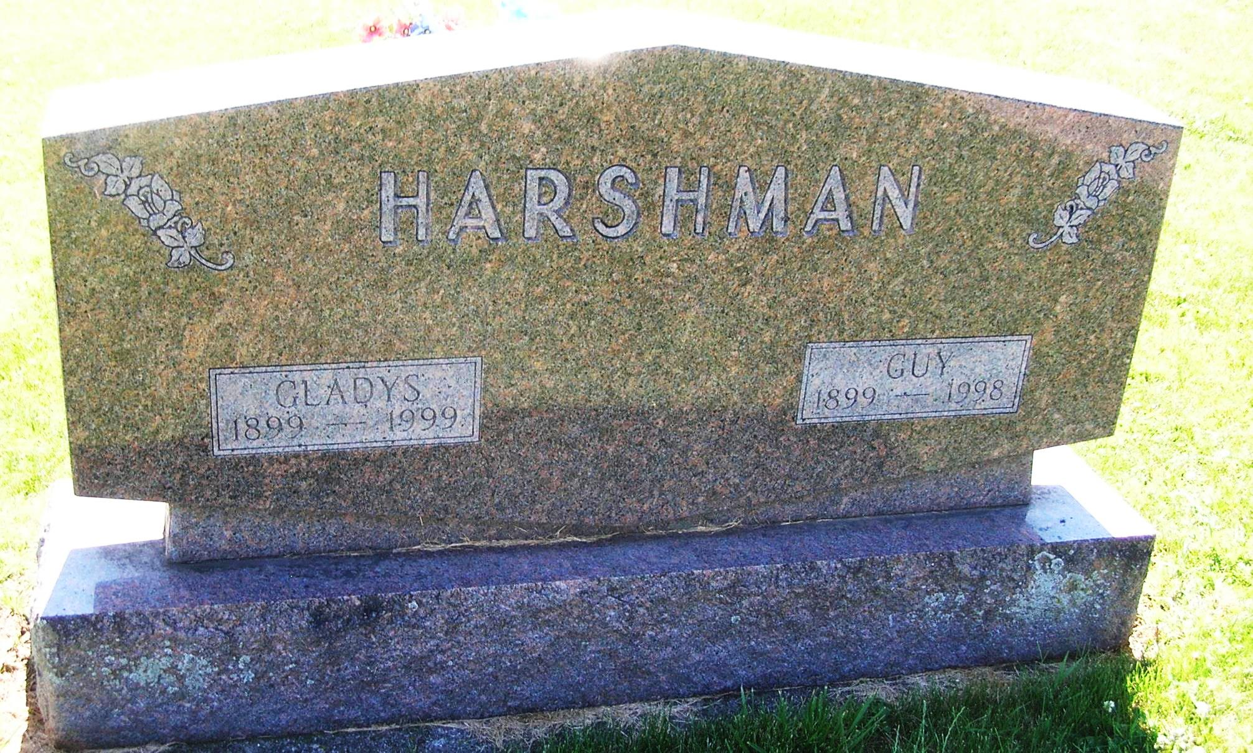
Portland -- GLADYS A. HARSHMAN, 100, died Thursday at Community Care East Nursing Home, Portland. Born in Jay County, she worked as a secretary at Sheller Globe Corp. for several years and later, with her husband, co-owned and operated a restaurant in Portland. They later owned and operated several apartment buildings in Portland. Her husband, Guy, died in 1998.
Surviving is a brother-in-law, Daniel P. Harshman, of Portland.
Services at 10:30 a.m. Saturday at Williamson & Spencer Funeral Home, Portland Chapel, with calling from 4 to 8 p.m. today. Burial at Little Salamonia Cemetery, near Portland.
Journal Gazette, The (Fort Wayne, IN) - Friday, May 21, 1999
Contributed by Jane Edson

