Robert E. Jellison
August 7, 1927 – November 9, 2011

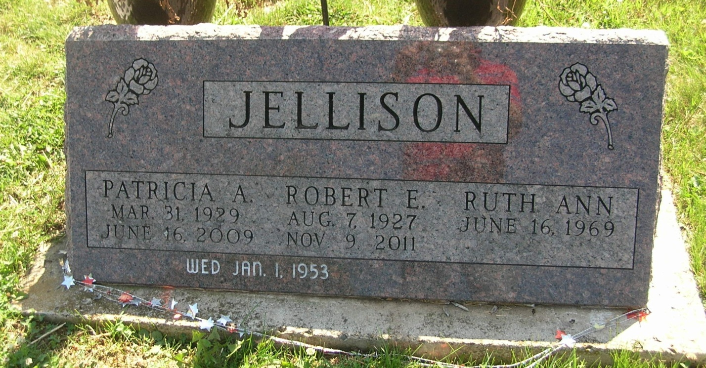
Robert E. Jellison, 84, 401 Canterbury Lane, Portland, passed away Wednesday in Persimmon Ridge Healthcare. He was born in Portland August 7, 1927, the son of Clarence and Geraldine (Stults) Jellison. He was married January 1, 1953 to Patricia Kunce and she died June 16, 2009.
He had worked at Jay Garment for 31 years, worked at Bearcreek Farms and Joe and Leo's Service Station. He was a U.S. Army Korean War veteran. He was a member of the A.A.R.P., American Legion Post #221, and attended Evangelical Methodist Church and Hopewell Life Ministries.
Surviving are two sons, Steven Jellison and David Jellison, both of Portland; three daughters, Becky Ballard, Debbie Hernandez and Ruth Jellison, all of Portland; one brother, Donald Jellison of Portland; one sister, Mrs. Merle (Helen) Shauver of Portland; nine grandchildren and 23 great-grandchildren.
Funeral services will be Saturday at 2 p.m. in the Baird-Freeman Funeral Home with Pastor Herb Hummel presiding. Visitation will be Saturday from 12-2 p.m. Memorials can be made to State of the Heart Hospice or Jay County Heart Fund.
Contributed by Jane – no source listed

