Nancy E. (Bailey) Spade
1869 – May 1, 1940

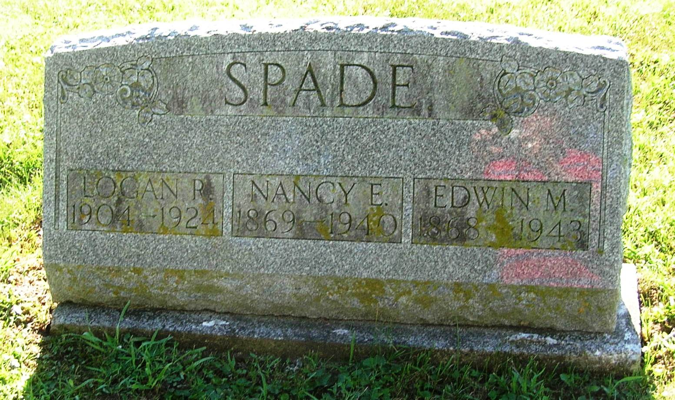
SPADE
Portland, May 2 – Funeral services for Nancy E. Spade, 71, will be conducted Friday afternoon at the Lower Salamonia Cemetery in charge of Rev. A. N. Shockney, pastor of the West Walnut Street Church of Christ. Interment will be in the Lower Salamonia Cemetery. Mrs. Spade died yesterday at her farm home two and one-fourth miles southeast of Portland. Surviving are the husband, E. M. Spade; two children, Mrs. Merlin Gaskill and Mrs. John Imel, both of southeast of Portland; two brothers, Harvey Bailey of five miles northeast of Portland and John Bailey of Albany and four grandchildren.
Journal-Gazette, Fort Wayne, IN; May 3, 1940
Contributed by Jim Cox

