Rose Marie (Irelan) Spitzer
March 21, 1933 – May 2, 1992

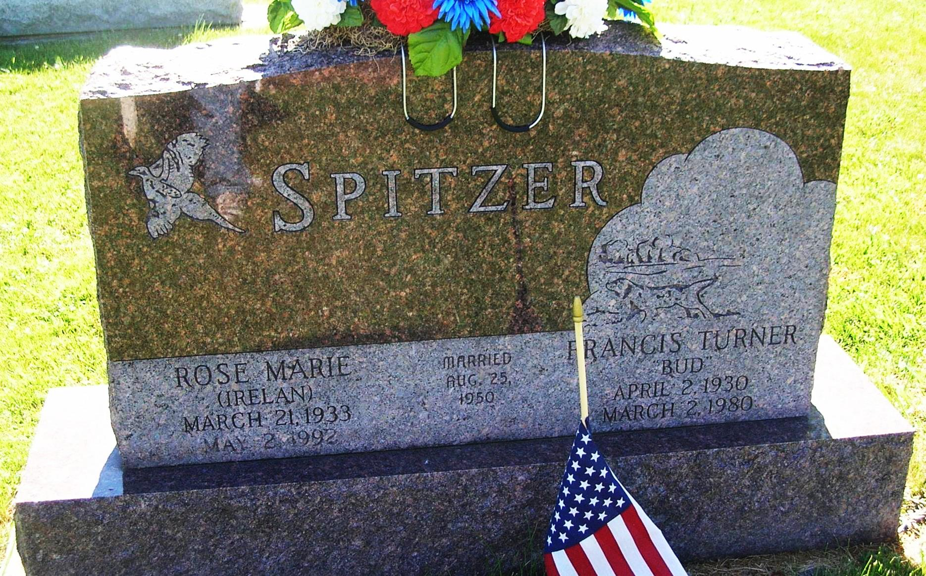
Rose Marie Spitzer, 59, Monticello, a native of Dunkirk, and former resident of Portland died Saturday night in Monticello Health Care Center after a long illness. She was a member of the Monticello Presbyterian Church and was involved in the Mary Martha Circle and Presbyterian Women’s Association of the church. She was also a volunteer at the Monticello Health Care Center. Born March 21, 1933, in Dunkirk, she was the daughter of William H. and Kathrn L. (Furrow) Irelan. She was married Aug. 25, 1950, in Portland, to Francis T. “Bud” Spitzer who died in 1980. A 1951 graduate of Portland High School, she moved to Monticello from Portland in 1958. Surviving are one son, Douglas S. Spitzer, Monticello; two daughters, Mrs. David (Kathie B.) Oudbier and Kristie E. McMasters, both of Monticello; one brother, James W. Irelan, Muncie; one half-brother, Michael Irelan, Dunkirk and two grandchildren. Services are set for 10:30 am Wednesday in the Voorhis-Draper Funeral Home, Monticello, with Rev. Edwin Morris and Dr. James H. Rucker officiating. Graveside services will be held at 3 pm in the Little Salamonia Cemetery in Jay County.
Commercial Review – Portland, IN; Monday, May 4, 1992
Contributed by Jim Cox

