Robert D. Stahl
July 6, 1937 – June 2, 2014

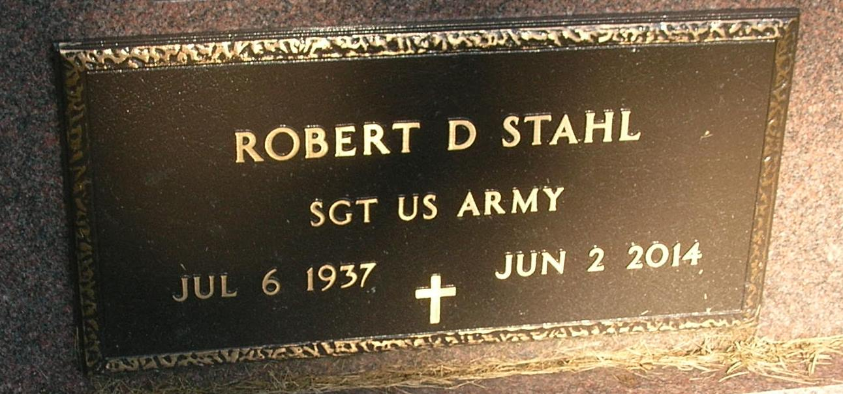

Robert Stahl, age 76, 137 Old Dawson Road Americus, Georgia passed away Monday in Americus. He was born in Portland July 6, 1937 the son of Henry E. and Myrtle Margarete (Hines) Stahl. He was married to Rachel Rines who survives. He was a farmer and contractor for Lockheed. He served with the U.S. Army and was a member of the Little Salamonia Church and attended Cornerstone Church in Americus.
Surviving are his wife Rachel, Two sons Dennis Stahl of Marietta, Georgia and Tim Shores (wife Kelli) of Poneto, IN., Three daughters Mrs. Kurt (Rebecca) Masek of Florence, Ky., Mrs. Brad (Maria) Trobridge of Americus, Georgia and Mrs. Gary (Rosalie) Steinle of Acworth, Georgia, Two sisters Sivilla Watson of Palm Harbor, Fl. and Dorothy Bechdolt of Omaha, NE. Eight grandchildren April (Shores) McElhaney, Aaron Schwieterman, Alicia Schwieterman, Grant Stahl, Riley Stahl, Evan Stahl, Vanessa Bolch and Kendra Sanders.
Funeral services will be Saturday at 10:00 A.M. in the Baird-Freeman Funeral Home with Pastor Kevin Brown presiding. Burial will follow in the Little Salamonia Cemetery. Visitation will be Friday from 6:00 to 8:00 P.M. and Saturday one hour prior to services. Memorials can be made to Phoebe Sumter Hospice or Cornerstone Church both of Americus, Georgia.
Baird-Freeman Funeral Home online obit (accessed 5/13/2015)

