Fred W Conkling
Dec. 19, 1920-Nov. 11, 2008
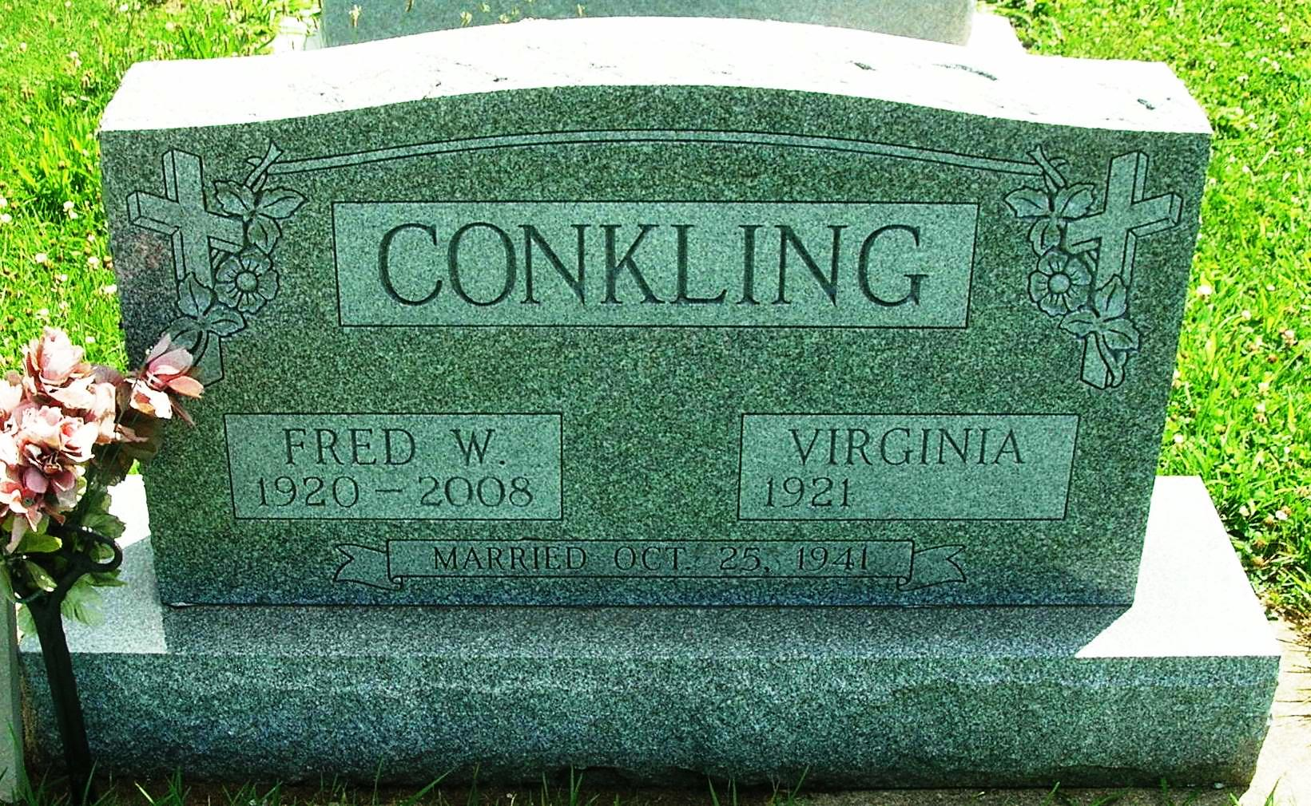
Fred W. Conkling, 87, 115 E. Baker St., Portland, died Tuesday at his home.
Born in Jay County to Fred W. and Flossie M. (Jones) Conkling, he was a graduate of Pennville High School. He was married on Oct. 25, 1941, to Virginia Paxson, who survives.
Retiring in 1986 as a truck driver, he was also a farmer. Memberships include Asbury United Methodist Church, Pennville Odd Fellows Lodge (since 1944) and American Trucking Association, where he received a 21-year safe driver 1,000,000 mile award.
Surviving beside his wife are a daughter, Credith Kraner, California; a sister, Anna Mae Conkling, Dunkirk; three grandchildren and one great-granddaughter.
Services are Saturday at 10 a.m. at Asbury United Methodist Church with Pastor Greg Rittenhouse officiating. Burial will be in the I.O.O.F. Cemetery in Pennville. Visitation is Friday from 3 to 8 p.m. at Baird-Freeman Funeral Home and one hour prior to services on Saturday at the church.
Memorials may be sent to the donor's choice.

Commercial Review, The (Portland, IN) — Thursday, November 13, 2008
Contributed by Jane Edson

