William L. Cromer
April 5, 1926 – July 17, 1952

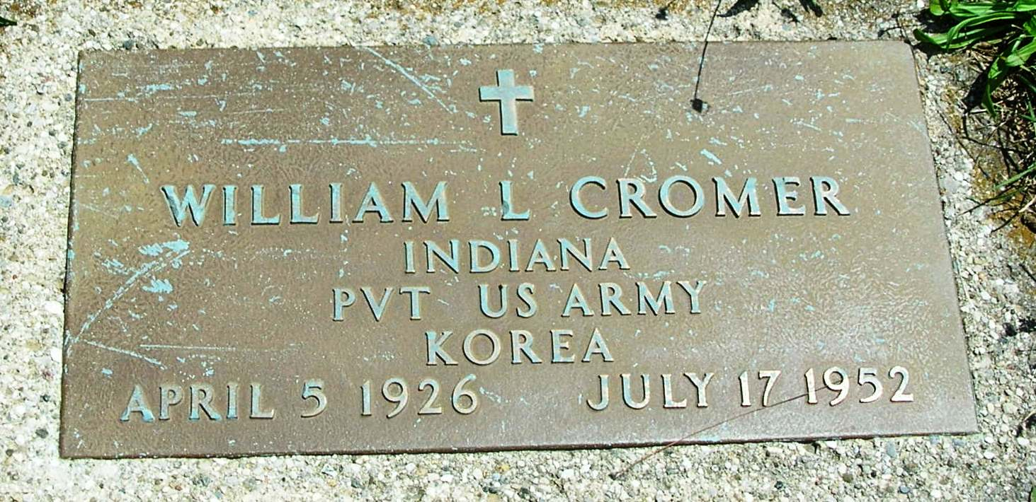

Hartford City Soldier Killed In Ohio Crash
Hartford City, Ind. (Spl) – Pvt. William L. Cromer, 23-year-old Hartfod City soldier, was killed yesterday at East Palestine, O., when his car struck the rear of a semitrailer.
Cromer’s wife, Marilyn, 20, who suffered shock, was taken to Salem (O.) City Hospital.
Pvt. Cromer was driving home on furlough after completing basic training at Fort Monmouth.
The Indianapolis Star (Indianapolis, Indiana) · Fri, Jul 18, 1952 · Page 10
Contributed by Jane Edson

