Reverend William A. Griest
1873 – June 8, 1953
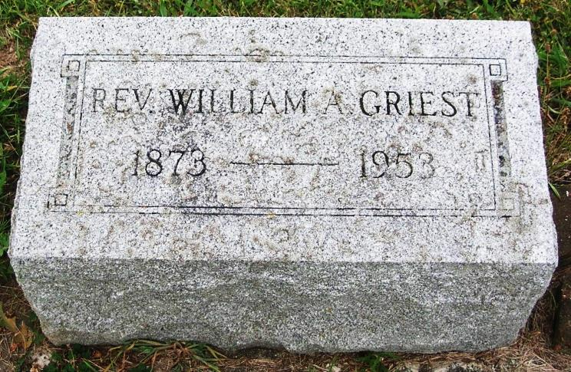

(Handwritten date: Tuesday, June 9, 1953)

REV. GRIEST, FOUNDER OF CHURCH DIES

The Rev. William A. Griest, 80, who founded the Simpson Methodist Church. 2501 S. Harrison St., in 1910, died Monday in the home of his daughter, Mrs. Robert D. Lahr, in Lafayette. He had been ill six months.
Reverand (sic) Griest also founded the Normal City Methodist Church in Muncie and the Fourth Ave. Church in Terre Haute. He was pastor in Anderson, Pendleton, Logansport, Brazil, Indiana Harbor, Rensselaer, Knox and Rominey. He retired in 1937.
He began his ministry as a professor at Taylor University in Upland in 1895 and entered the North Indiana Conference of the Methodist Church in 1896.
PASTOR IN 1907
Before coming to Fort Wayne Reverand Griest served as pastor in Pendleton in 1907, '08 and '09. In 1910 he began the building campaign for the Simpson Methodist Church in Fort Wayne which was dedicated Feb. 11, 1912, with a membership of 300.
Remaining here as pastor of the Simpson Church until 1914, he went to the Market Street Methodist Church in Logansport where he served as pastor in 1915 and 1916. He was transferred out of the North Indiana Conference in 1920.
Reverand Griest founded the Normal City Church in Muncie in 1900 and remained there through 1902. This church is now known as the College Avenue Methodist Church.
Funeral services will be held at 9:30 a.m. Wednesday.

Karin King note: Rev. Griest is buried in Twin Hill Cemetery, Pennville, Indiana

Adams County Historical Museum 1933-1953 Scrapbook, Image 029
Transcribed by Karin King

