Ruth E. (Egnew) Hilton

1928 – December 17, 2006

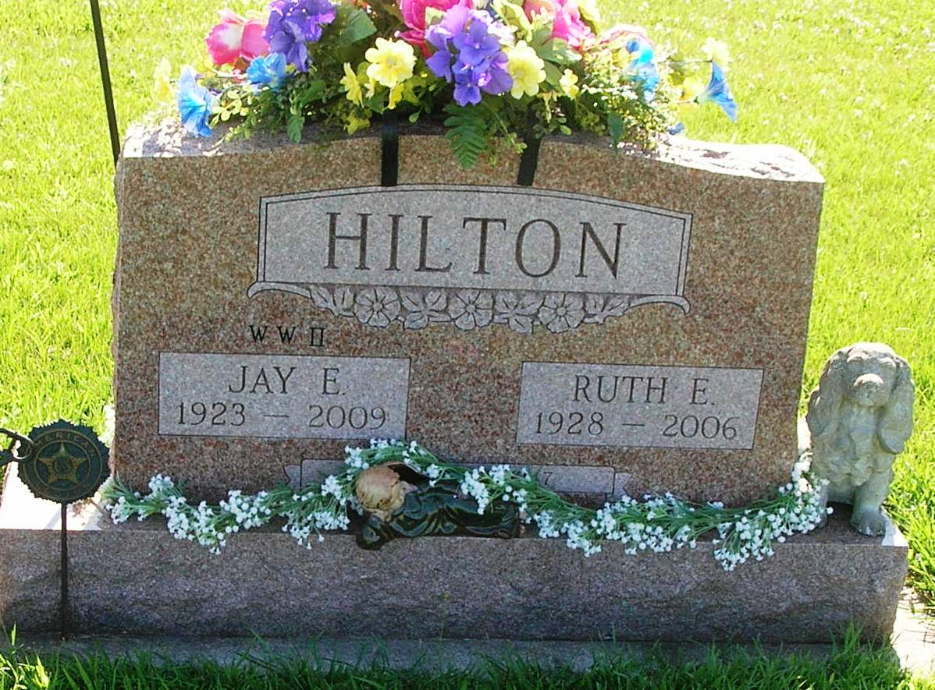

RUTH E. HILTON, 78, of Pennville, Ind., died Sunday, Dec. 17, 2006. Arrangements by Williamson & Spencer Funeral Homes, Inc.

Journal Gazette, The (Fort Wayne, IN) - Tuesday, December 19, 2006
Contributed by Jane Edson

