Joyce Elaine (Zehner) Hudson
June 20, 1943 – March 20, 2017

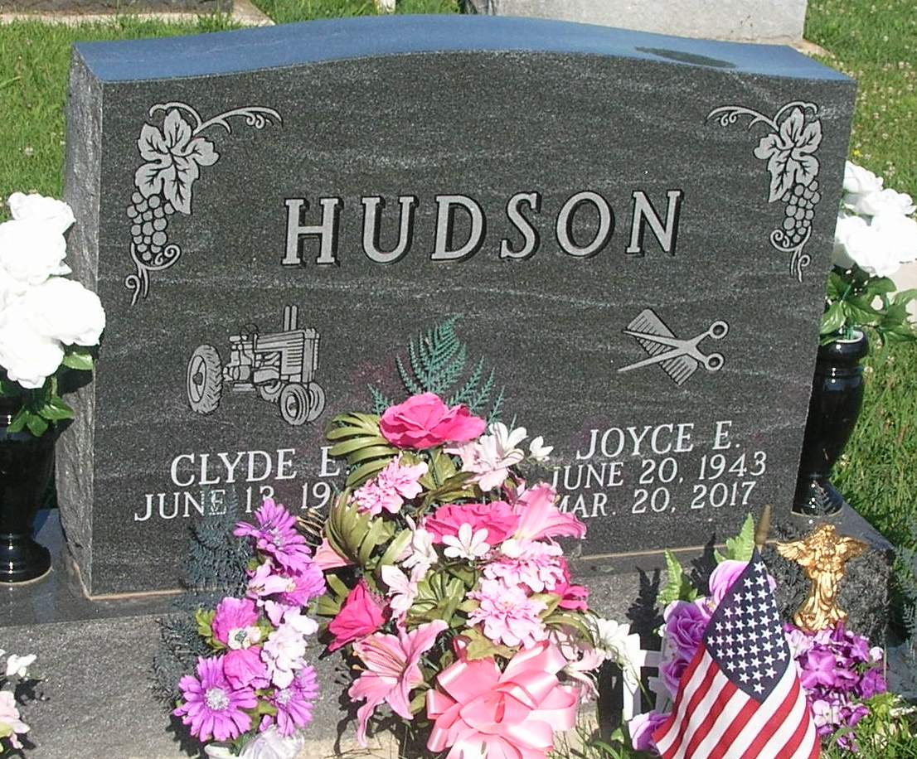
Joyce Elaine Hudson, 73, of rural Pennville, IN, passed away on Monday, March 20, 2017 at her winter home in Brooksville, FL. She was born on Sunday, June 20, 1943 in Wells Co. Indiana. She was married to Clyde Hudson on Saturday, September 1, 1962 in Montpelier, IN. Joyce was a 1961 graduate of Montpelier High School in Blackford county. Joyce worked as a Hair Dresser for over 30 years at her home in Pennville, IN and beauty shop in Montpelier, IN. She retired in 2002 and began spending winters in Brooksville, FL in 2011. Joyce was a member of Beta Sigma Phi Sorority. She enjoyed watching sports, and spending time with her family and grandchildren. Joyce was a member of Union Chapel Church of the Nazarene.
Loving Survivors of Joyce are her Husband- Clyde Hudson, Pennville, IN, Son- Blake Hudson, Ft. Wayne, IN, Daughter- Faith (Husband, Lewis) Merchant, Montpelier, In, Grandchildren- Terrence Merchant, Shea Merchant, and Chantel Merchant, Sister- Nancy (Jay) Beaver.
Joyce was preceded in death by her Father- Gerald Zehner, Mother- Faye (Hiser) Zehner, Brothers- Jackie Zehner and Bobbie Zehner.
Friends and family may gather to share and remember Joyce at Walker & Glancy Funeral Home 109 W. Windsor St. Montpelier, IN on Saturday, March 25, 2017 from 2:00 p.m. till 8:00 p.m.
Funeral services will be held at Walker & Glancy Funeral Home at 1:00 p.m. on Sunday, March 26 ,2017 with reverend Dewey Zent officiating. Interment will follow in the Twin Hill-I.O.O.F cemetery, Pennville, IN.

Glancy Funeral Homes online obit (accessed 9/22/2017)

