Robert Duane Hudson
1933 – February 26, 2016

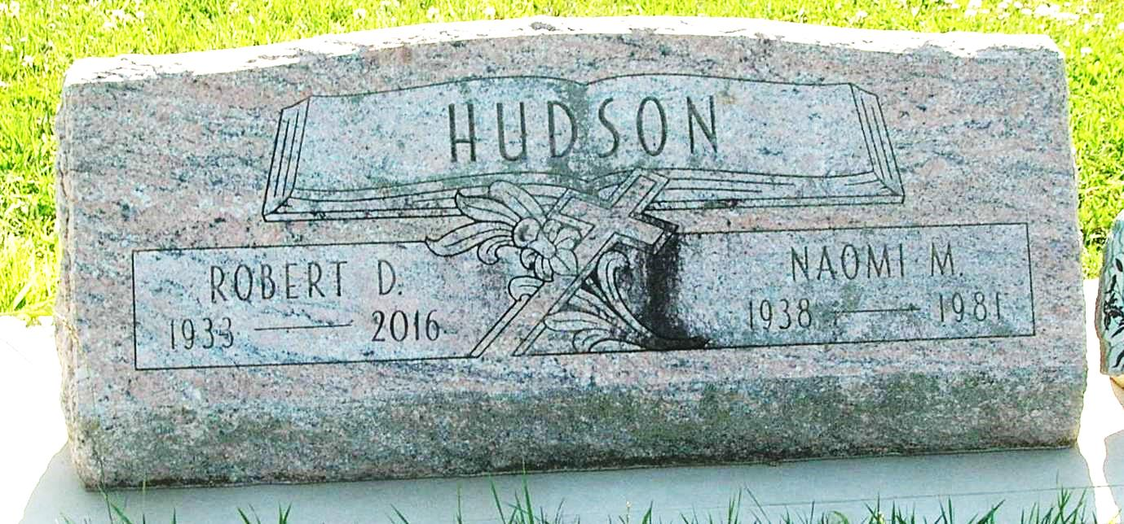
Robert "Bob" Duane Hudson, 82, Avon Park, FL, received his eternal reward at 10:16 p.m. on Friday, February 26, 2016. Bob was born in Portland, IN, to the late Ralph and Ethel (Hutson) Hudson. He was married to Naomi (Horn) Hudson until she went to be with the Lord on June 10, 1981. Bob then married Bonnie B. McCullough on July 7, 1984, and she survives.
Bob graduated from Gray High School, Redkey, and received his Associate's Degree from Indiana Business College. He was a U.S. Army veteran, who served his country from 1954-1956. While living in Portland, Bob was Comptroller at Forge, and he attended Oak Grove Church. He moved to Marion and was a hog farmer while also being employed as Treasurer at World Gospel Mission (WGM), where he served for 25 years until his retirement. Bob was a member of Pioneer Faith Evangelical Church during his years in Marion. Following his retirement, he and Bonnie moved to Florida, and he served as Treasurer of Avon Park Holiness Camp.
Bob was a quiet and unassuming man with a dry sense of humor. His love for the Lord and his family was very evident. Bob had a very giving and generous nature that was not limited to just his local community. While working as WGM's Treasurer, he regularly traveled to many of its mission fields, such as Arizona (Southwest Indian School), Africa, and Honduras. One place, however, left a lasting impression on Bob's heart and life—Escuela El Sembrador, a boarding school in Honduras dedicated to reaching neglected children through education and agriculture. Bob touched numerous lives literally world-wide, and he will be greatly missed.
In addition to his wife, Bonnie, of 31 years, survivors include his children, Duane (Judy) Hudson, Fairmount, Kathy R. (Jeff) Steege, Windemere, FL, Kimberly F. Collier, Anderson, and Dan (Laurie) Hudson, Marion; son-in-law, Jeff Smith, Wixom, MI; 9 grandchildren, Lindsey and Leslie Hudson, Jessalyn and Kaitlyn Smith, Joshua, Tyler, and Nathan Collier, and Darian and Dylan Hudson; and brother, Jerry D. Hudson, Portland.
Also preceding him in death were his daughter, Karen K. Smith; son-in-law, Jonathan Collier; grandson, Jerrod Robert Smith; and brother, Donald Hudson.
The family will receive visitors from 2-8 p.m. on Friday, March 4, 2016, at Needham-Storey-Wampner Funeral Service, Storey Chapel, 400 E. Main St., Gas City, IN.
A Celebration of Life service will be at 10 a.m. on Saturday, March 5, 2016, at World Gospel Mission, 3783 St. Rd. 18 E., Marion, with Rev. David Kushman officiating. Additional visitation will be one hour prior to the service. Burial will follow at IOOF Cemetery in Pennville, IN.
Contributed by Lynn Stoops Chapel – no source listed

