June (Harshman) Kerns
July 26, 1934 – July 10, 2017

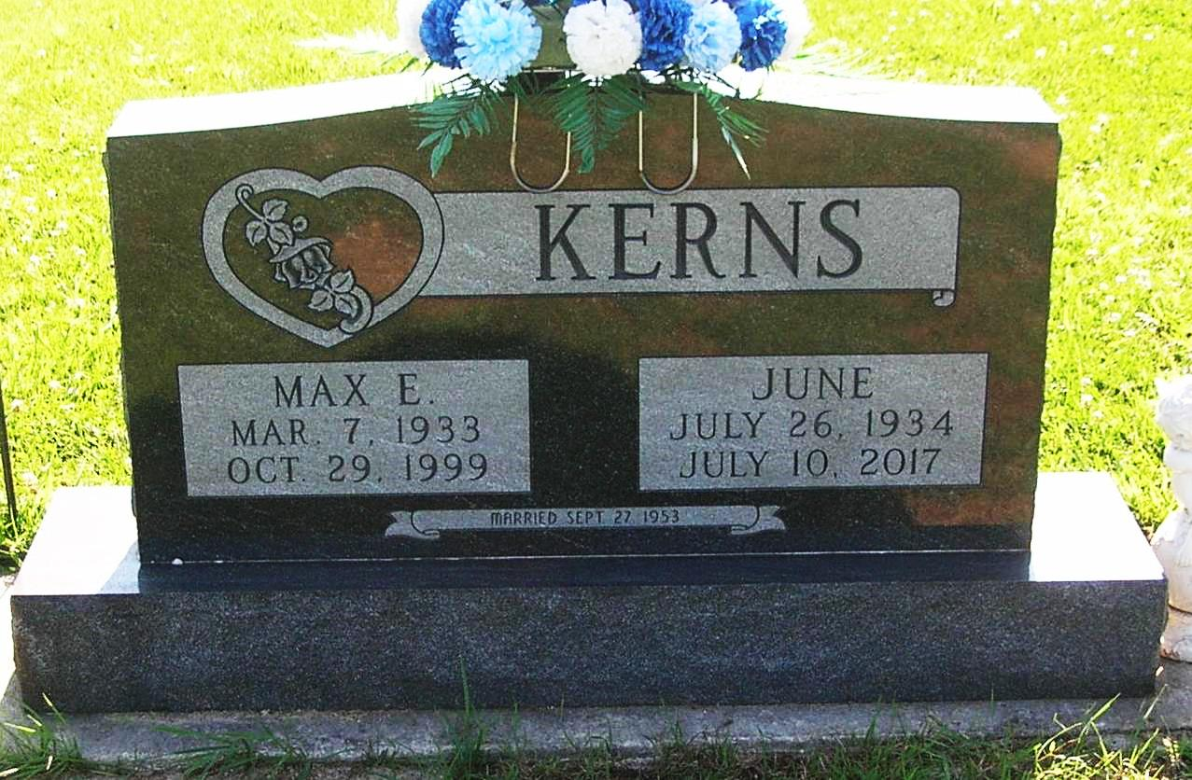

June Kerns, 82, of Bluffton passed away at 11:20 A.M. on Monday, July 10, 2017, at Bluffton Regional Medical Center.
June was born on July 26, 1934 in Wells County, Indiana to Ralph & Nancy (Swartz) Harshman. She graduated from Petroleum High School with the class of 1952. On September 27, 1953 in Portland, Indiana, June and Max E. Kerns were married. They lived in Alaska from 1953 to 1955, while Max was stationed at Fairbanks in the U.S. Army. They moved back to Randolph County until 1992, when Max and June moved back to Wells County and called Bluffton home. June retired from Bluffton Regional Medical Center where she worked in the Medical Transcription department.
Survivors include a daughter Lori Kerns of Bluffton along with siblings: Moretta (Larry) Eads of Berne, LeRoy (Elaine) Harshman of Pennville, and Wilma Baumgartner of Fort Wayne, Deewayne “Ralph” (Marcy) Harshman of Fort Wayne, Brenda Harshman of Hamilton, WA, David (Rhonda) Harshman of Rochester and Paul (Diane) Harshman of Pointe Isabel, IN.
She was preceded in death by her husband Max on October 29, 1999 and an infant daughter Lisa Kerns.
A service to celebrate June’s life will be held at 10:30 A.M. on Friday (July 14, 2017) at the Thoma/ Rich, Lemler Funeral Home in Bluffton. Rev. Cindy Osgood will officiate. Calling hours will take place from 2 P.M. to 8 P.M. on Thursday at the funeral home. Burial will follow at I.O.O.F. Cemetery in Pennville. Memorials may be made in June’s memory to the American Diabetes Association.
Funeral arrangements have been entrusted to the care of the Thoma/Rich, Lemler Funeral Home in Bluffton
Thoma/Rich, Lemler Funeral Home online obit (accessed 07/11/2017)

