Karen B. (Platt) McFarland
August 8, 1940 – September 21, 2017

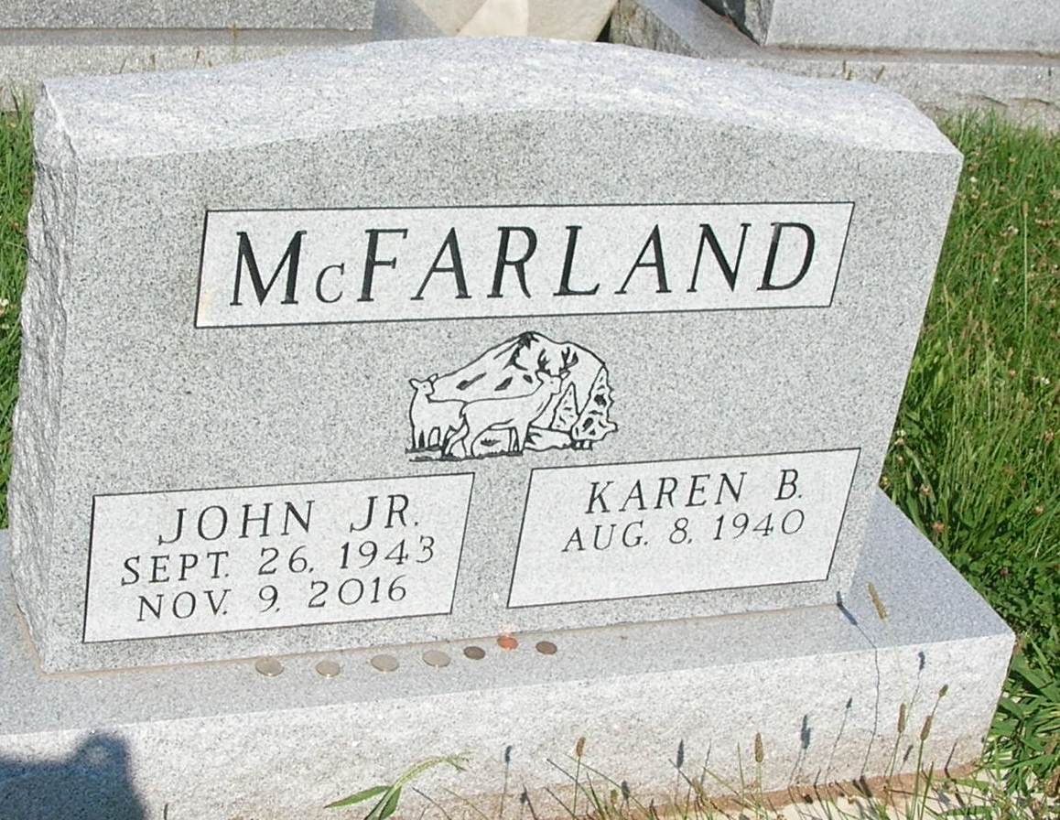

Karen McFarland, age 77, a Pennville resident, passed away Thursday, September 21, 2017 at Miller’s Merry Manor in Dunkirk. She was a homemaker and a member of the Pennville American Legion Auxiliary.
Karen McFarland was born August 8, 1940 in Rosie, Arkansas the daughter of Roy and Vivian (Gower) Platt. She was married November 12, 1971 to John McFarland Jr. and he passed away November 9, 2016.
Survivors Include:
1 Son- Kevin Taylor, Pennville, Indiana
2 Daughters- Twila Wimmer, Muncie, Indiana
Yvonna Cable, Montpelier, Indiana
18 Grandchildren, 21 Great Grandchildren and 1 Great Great Grandchild
She was preceded in death by a son, Gerry Taylor in 2016.
Funeral services will be held at 3:00pm on Monday in the Pennville Chapel of the Williamson and Spencer Funeral Home. Visitation will be held from 1-3pm on Monday at the funeral home prior to the services. Burial will be held at a later date at IOOF Twin Hills Cemetery.
Memorials may be directed to Riley Children’s Hospital.

Williamson & Spencer Funeral Home online obit (accessed 09/22/2017)

