Eva Marie (Miller) Nibarger
September 7, 1934 - September 23, 2009
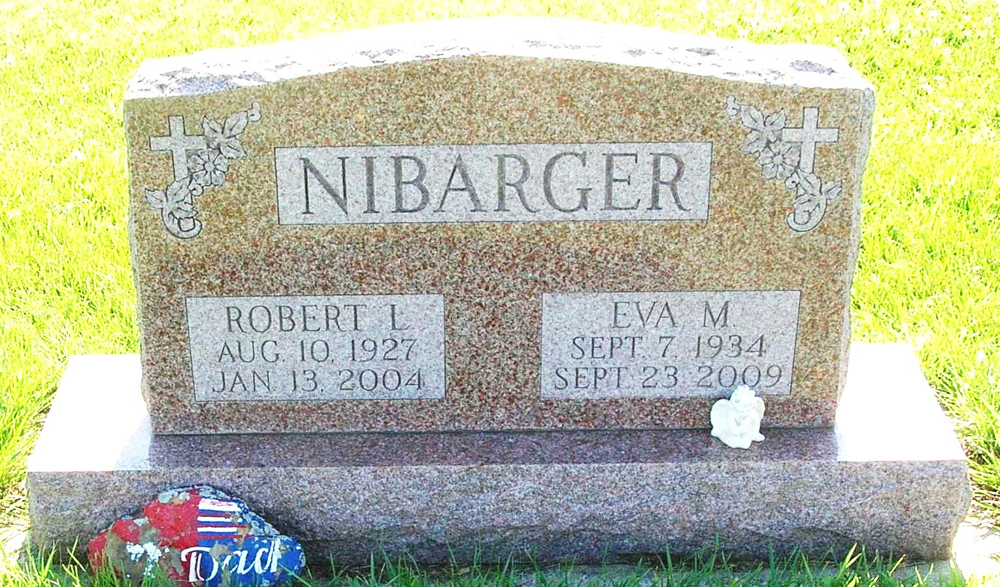
Eva Marie Nibarger, 75, Crosby, Texas, died Wednesday at San Jacinto Methodist Hospital in Houston, Texas. A former Dunkirk resident, she moved to Crosby in 2004.
Born in Dunkirk to Ray and Pauline (Robinson) Miller, she was preceded in death on Jan. 13, 2003, by her husband Robert L. Nibarger, whom she married on Nov. 21, 1950.
Survivors include three daughters, Mary Ann Clark, Bryan, Texas, Mrs. Don (Vicky S.) Grubb, Crosby, and Lucinda J. Reff, Pasadena, Texas; two sons, Robert A. Nibarger Jr. and Thomas L. Nibarger, both of Crosby; a sister, Mrs. Robert (Margaret) Stump, Union City, Ohio; 15 grandchildren and 32 great-grandchildren.
Services are Monday at 11 a.m. in the Pennville Chapel of the Williamson and Spencer Funeral Home with the Rev. Daniel Sickels officiating. Burial will be in the I.O.O.F. Twin Hills Cemetery in Pennville. Visitation is Sunday from 2 to 4 p.m. at the funeral home.
Condolences may be sent to www.williamsonspencer.com.
Commercial Review, The (Portland, IN) - Friday, September 25, 2009
Contributed by Jane Edson

