Robert L. Nibarger
August 10, 1927 – January 13, 2004

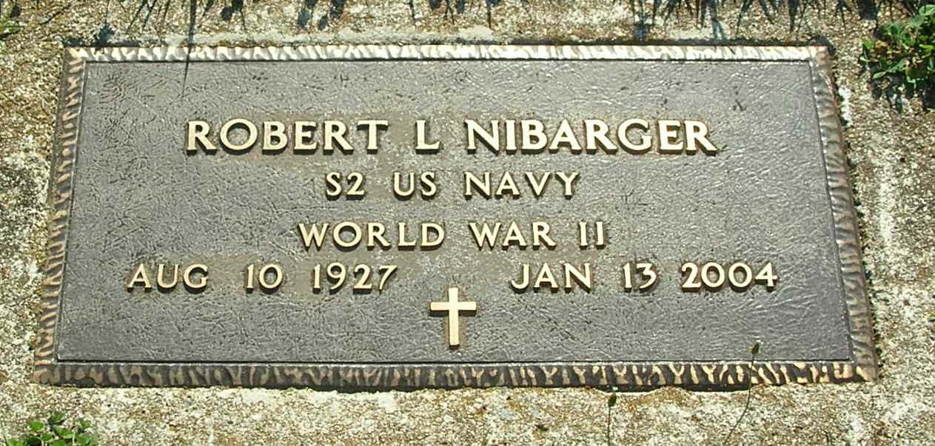

Robert L. Nibarger, 76, South Main Street, Dunkirk, died Tuesday at Ball Memorial Hospital, Muncie.
Born in Pennville on Aug. 10, 1927, to George and Pauline (Bye) Nibarger, he married Eva Marie Miller who survives.
An Army and Navy veteran of World War II, he was formerly a machinist at Delaware Machine in Muncie. He was a member of the American Legion Post No. 211, Portland, and the VFW Post No. 7081, Dunkirk.
Other survivors include two sons, Robert and Thomas Nibarger, both of Crosby, Texas; three daughters, Mrs. Milt (Mary) Clark, Bryan, Texas, Mrs. Donnie (Vicky) Grubbs, Las Vegas, Nev., and Lucinda Reff, Pasadena, Texas; four brothers, Richard Nibarger, Pennville, Tony Nibarger, Montpelier, Thomas W. Nibarger, Colorado Springs, Colo., and Roger Nibarger, Dunkirk; three sisters, Mrs. Johnny (Betty Lou) Young, Redkey, Virginia Poling, Dunkirk, and Mrs. Roger (Sue) Grayson, Marion; 14 grandchildren; and 13 great-grandchildren.
Services are Monday at 2 p.m. at M.J.S. Mortuaries-D.W. Jones Chapel, Dunkirk, with burial following in the Pennville I.O.O.F. Cemetery. Military graveside rites will be conducted by VFW Post No. 7081, Dunkirk, and American Legion Post No. 211, Portland. Visitation will be held on Sunday from 2 to 4 p.m. at the mortuary.

Commercial Review, The (Portland, IN) — Friday, January 16, 2004

Contributed by Jane Edson

