Doreen (Dotson) Oliphant

February 18, 1944 - August 15, 2013

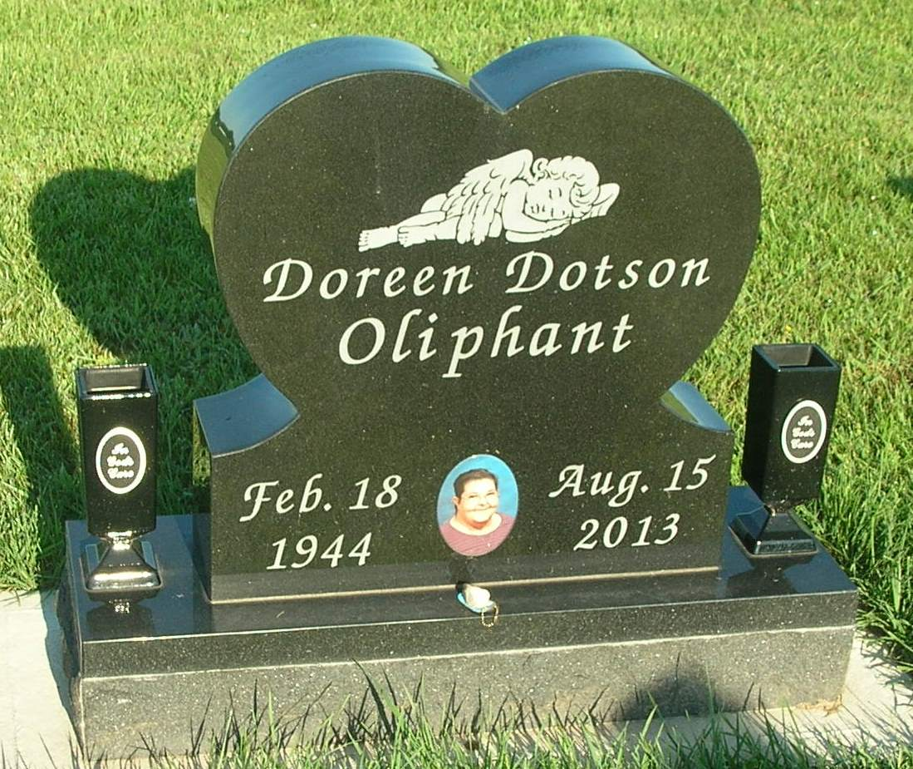

Jeannie Doreen (Dotson) Oliphant, 69, Fishers, died Thursday at her home. Born in Huntington to Winifred (Welch) Robertson and Warren McMillian, she worked as an inspector at the former Kerr Glass in Dunkirk. She is survived by a daughter, Kim Jones, Fishers; and four sons, Scott Jones (wife: Cathy), Oakridge, Tenn., Tom Clevenger (wife: Cheryl), Fishers, and Randy Clevenger and J.J. Dotson, both of Muncie. She is also survived by two sisters, Carlene Sampley and Renée Blumenhorst (husband: Terry), both of Dunkirk; two brothers, Eugene Robertson and Tony Robertson, both of Muncie; 13 grandchildren; and several nieces and nephews. Services will be 2 p.m. Tuesday at MJS Mortuaries Dunkirk Chapel with Pastor Denney Helton officiating.
Commercial Review, The (Portland, IN) - Saturday, August 17, 2013
Contributed by Jane Edson

