James E. Steed

May 23, 1956 - January 28, 2013

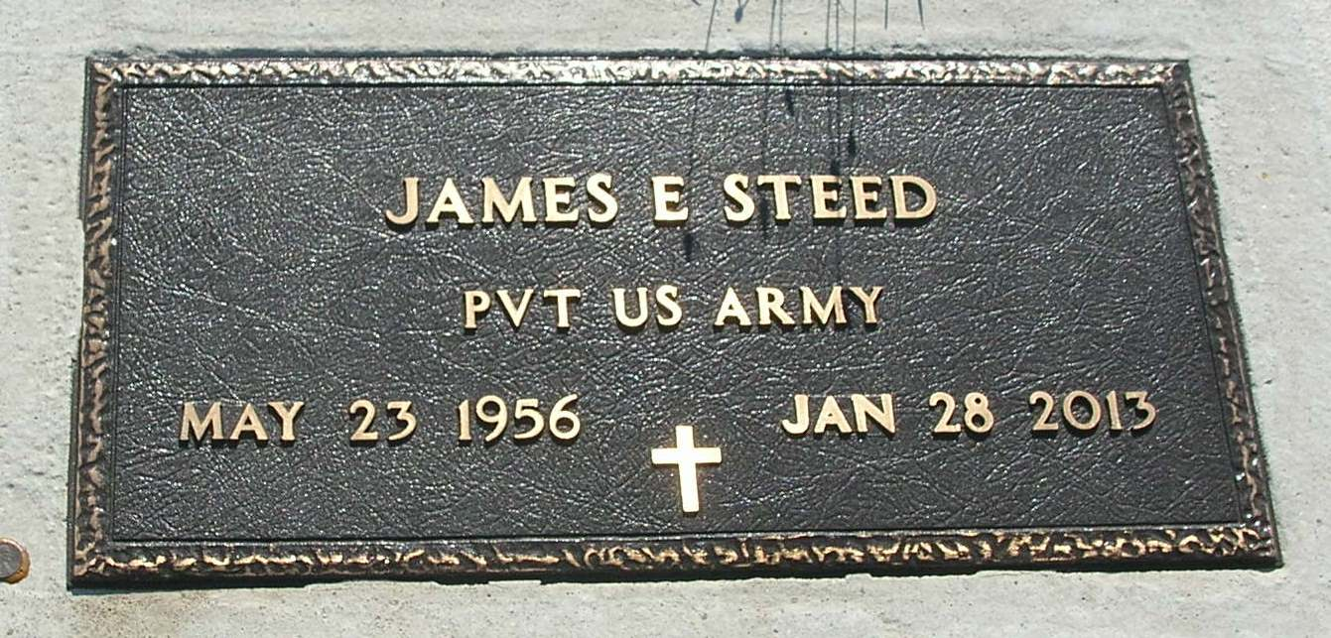

A memorial service for James E. Steed, 56, Portland, will be held Saturday at 2 p.m. at Redkey United Methodist Church. He died Jan. 28 in Portland. Born in Portland to James D. and Carolyn (Robbins) Steed, he is survived by his companion Shirley Laisure, Portland. A veteran of the United States Army, he was a truck driver and member of the American Legion and Portland Eagles Lodge. Surviving, besides his companion, are a daughter, Casandra Prox, Portland; two sisters, Tina Gillum, Portland, and Jennifer Bumbalough, Redkey; and two grandsons. Condolences may be sent to www.bairdfreeman.com.

Commercial Review, The (Portland, IN) - Wednesday, February 6, 2013
Contributed by Jane Edson

