Edna L. (Cline) Van Note

May 7, 1933 - December 13, 2012

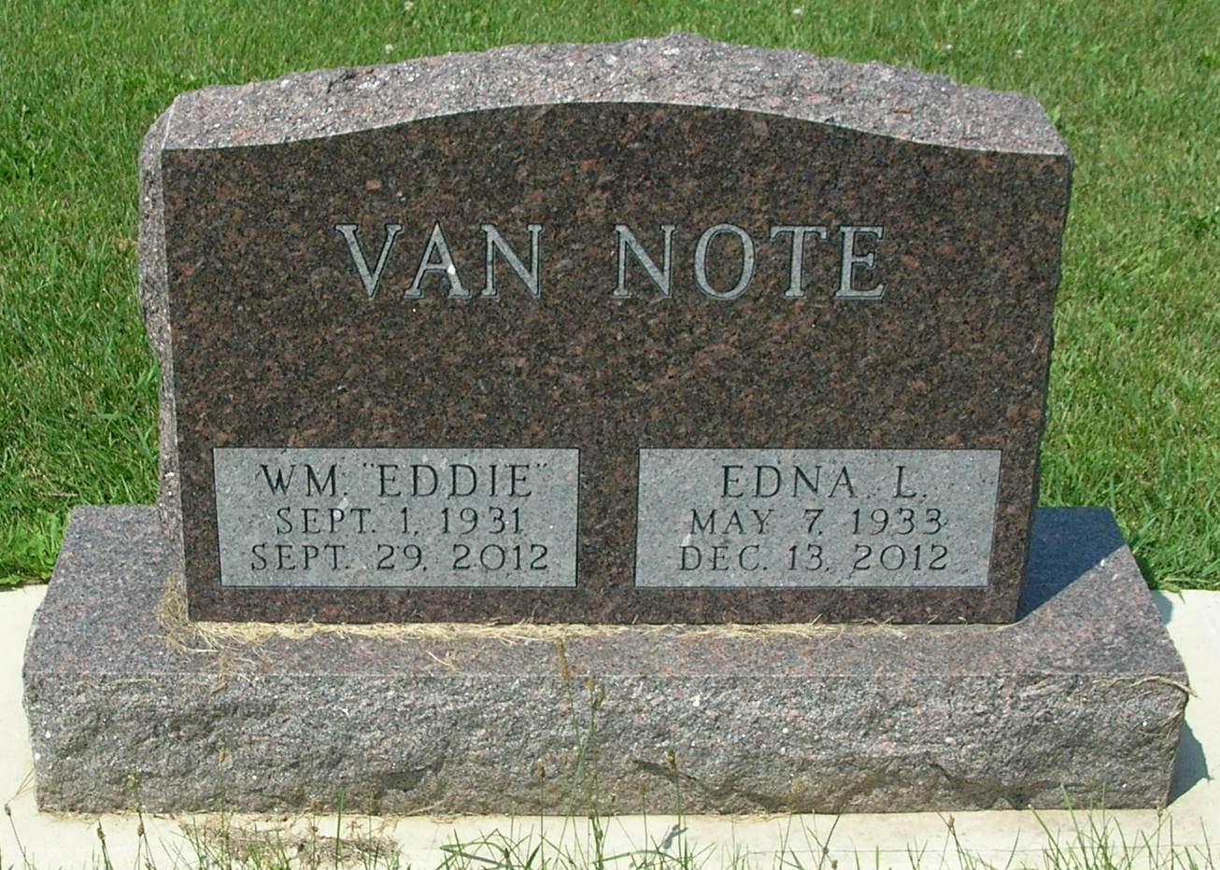

Services for Edna L. VanNote, 79, Elkhart, a former rural Bryant resident, will be held Tuesday at 11 a.m. at Williamson and Spencer Funeral Home, Portland, with Pastor Phill Jellison officiating. A Pennville native, she died Thursday at the home of her daughter in Elkhart. The daughter of Chester E. and Fay B. (Shannon) Cline, she graduated from Pennville High School in 1951. She was worked for Carl Steed and Associates, May Insurance Agency and Pennville Custom Cabinets, all in Portland, and also served as secretary for the Portland chapter of Disabled American Veterans. She attended Macklin Chapel, Bryant, and Gospel Lighthouse Church, Portland. She was married Aug. 5, 1967 to Hansel Reese, who died Dec. 24, 1987. She was married Sept. 18, 1989 to William Edward VanNote, who died Sept. 29. Survivors include a daughter, Fayellen Marie Haeck (husband: Mark), Elkhart; two stepsons, Tony W. VanNote (wife: Marcie), Lynn, and Jerry VanNote (wife: Darla), Winchester; a brother, Gerald Cline, California; five grandchildren; five great-grandchildren; five step grandchildren and several step great-grandchildren. Visitation will be Monday from 4 to 8 p.m. at the funeral home, and burial will follow services Tuesday at IOOF Twin Hill Cemetery, Pennville. Memorials may be made to Alzheimer's Association, and online condolences may be made at www.williamsonspencer.com.

Commercial Review, The (Portland, IN) — Saturday, December 15, 2012
Contributed by Jane Edson

