James Albert Bickel
January 12, 1848 – February 8, 1916
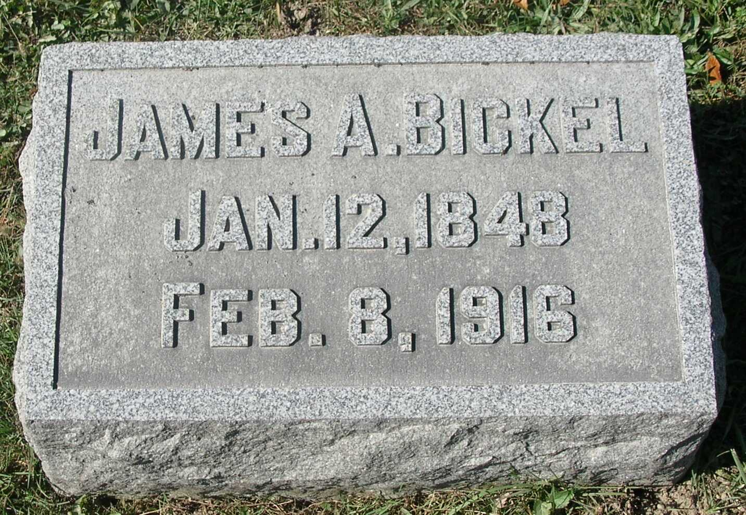

Newspaper Clipping – estimated date 1916

James Albert Bickel, husband of Martha Angeline (Patterson) Bickel, was born in Jay county, Jan 12th 1848, and departed this life Feb. 8th 1916 at his late home on South Meridian street, in the city of Portland, Ind., he being at the time of his departure aged 68 years, 3 months and 6 days.
He was united in marriage to Martha Angeline Patterson, Nov. 30th, 1879. To this union there were born ten children, three daughters and seven sons, of this number two of the sons out went him to the great beyond, they were Thomas A. and (?..ron) Everett. Those who remain to mourn his going are Lillie May Schwartz, wife of O.F. Schwartz of near Portland, Albert Dwain, of Arizona; Esther Christina, wife of Jasper O. Paxton, of near Zoar, Jay county; Martha Angeline, wife of Haskel Warner, of Portland; Charles O. of Pike township; James Leonard; William Edicott; Lacy Otto at home; his wife, five half brothers who are A.J., William, Luther, Charles and W.D. Ashley, all of Jay county, also one-half sister; Mrs. Nanna E. Wall of Kansas. He was preceded in death also by one half sister, Clarinda O. Ashley.
James was a well known business man, having engaged in business as clerk in one of Portland's mercantile establishments when but a young man. Later on entering business for himself and those who have known and dealt with him in a business way speak of him in highest terms, as to his honesty and integrity. All his life has been spent in Jay county and until about one and one-half years ago his home was in Pike township, at that time having moved to Portland, Indiana, where the death messenger overtook.
James never belonged to any church yet he has always been a believer in churches, and for some time before the end came he, as he expressed it, had got right with God, and he so expressed himself to others. So comes to close one of Jay county's life-long citizens. We turn sadly away but not to mourn as those who have no hope.

Card of Thanks
We, the family in this manner desire to thank all who in any way lightened the burdens during the sickness and death of our dear one, and we want to especially thank the First National Bank of Portland for the flowers sent to the home during the sickness of our loved one and for the many beautiful tokens of friendship and sympathy so expressed by the floral offerings. Funeral conducted from the Zoar M.E. church, Saturday, Feb. 12, 1916, at about 2 p.m. by Rev. J.H. Nall of the U.B. church, assisted by Rev. Hurlburt of the ( ) with interment in Zoar cemetery.

Submitted by: Mary Lou Hudson

