Andrew McCartney
November 9, 1803 – September 5, 1883
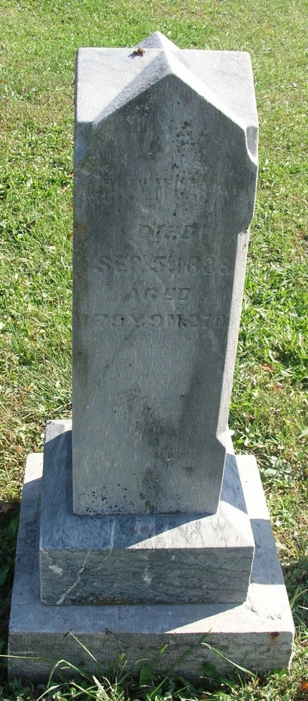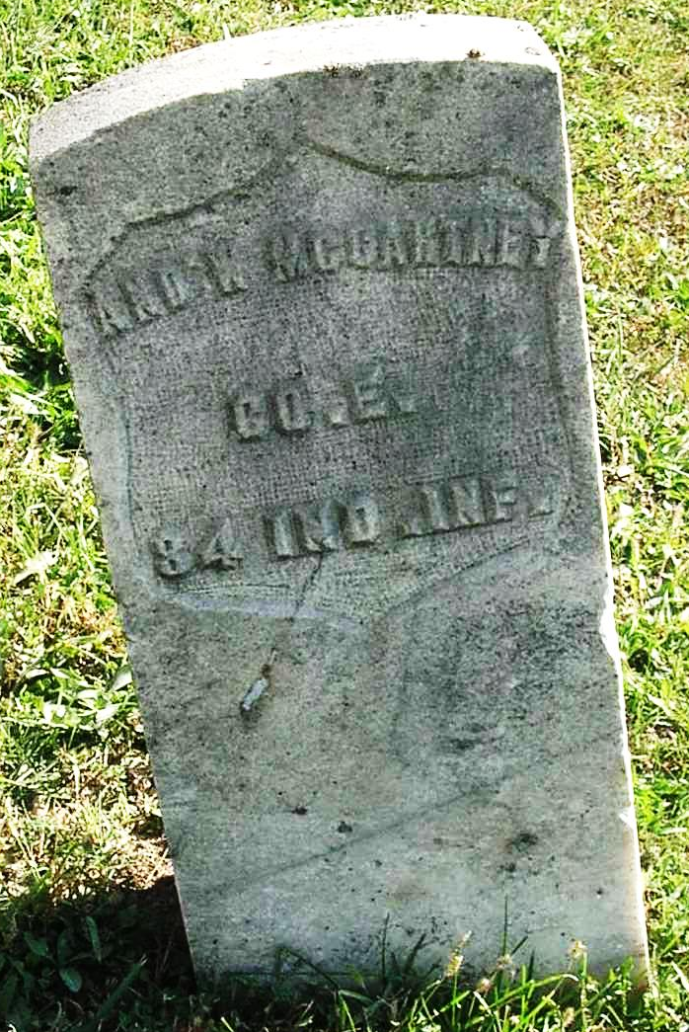
OBITUARY
September 9, 1883: Dies at this place last Thursday, Andrew McCartney, an old resident, aged 79 yr and 11 months. The Deceased moved to this county in 1835 and has been a resident since that time until his death except about one year during the late war he served as a member of Company E, 84th Indiana Volunteers until discharged on account of disease contracted in the service. He was the father of 24 children, 11 of whom are living. He was a kind and good citizen and was generally respected by all. His remains were interred at Zoar Church Cemetery, Jay county, on Friday. The old gentleman now sleeps the sleep that knows no waking. Let his good actions live after him. Let his faults, if any he had be interred with his bones. His children here with whom he resided wish to thank the friends and neighbors for their assistance and attention during the last illness of the deceased.
Contributed by DSON1492 – no source listed

