Susan (Feasle) Ware
December 28, 1819 – April 8, 1900
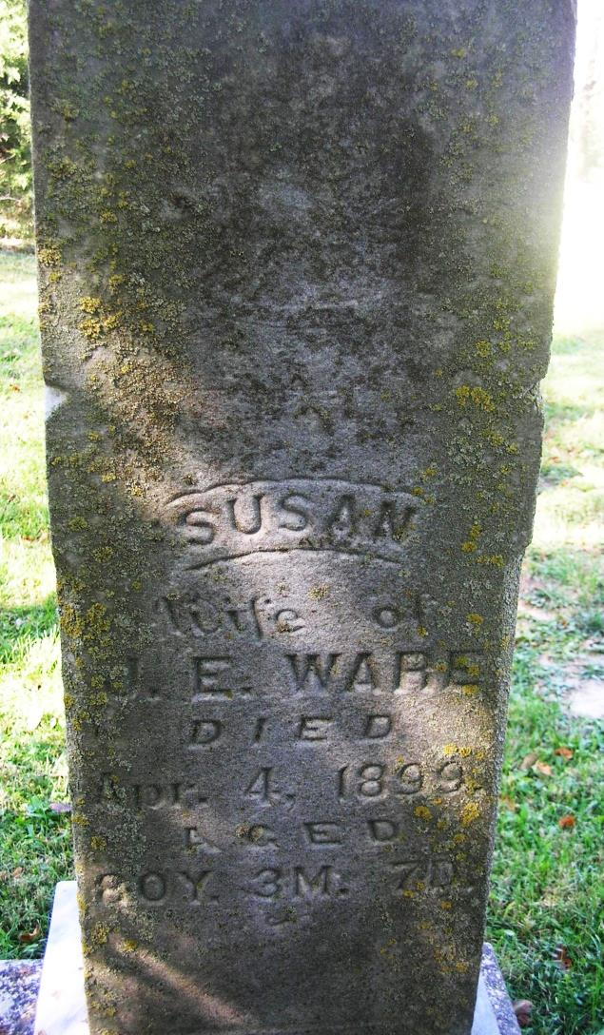
Susan Feasle Ware died Sunday, aged 81 years, 3 months and 27 days at her home four miles south of town. She was born in Washington County, Tennessee on January 1, 1819. She was married to John Eldridge Ware. To them were born nine children, four daughters and five sons. Three sons and one daughter have preceded her to the better land. She lived a widow thirty-two years and spent nearly sixty years of her life in Jay County. She was brought up in the Quaker faith. Funeral services at Zoar today, Tuesday at 10 o’clock. She had lived in this county for sixty years. Her husband, who has been dead for thirty years, cleared twenty-five acres of the ground where Portland stands.
Portland Sun, Jay County, IN; Tuesday, April 10, 1900
Contributed by Jim Cox

