LARRY GENE BURKHOLDER

is honored on Panel 17W, Line 44 of the Vietnam Veterans Memorial.
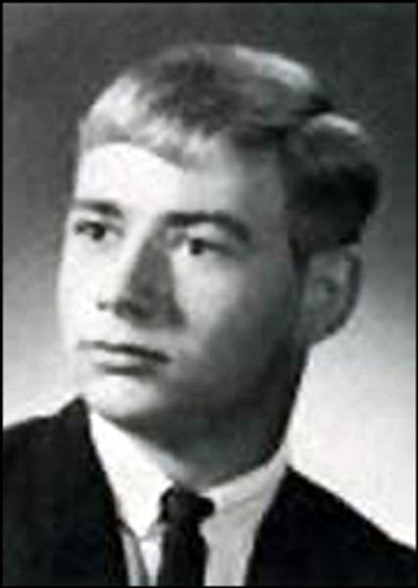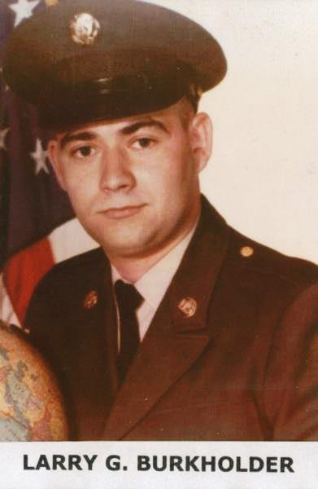
- Wall Name: LARRY G BURKHOLDER
- Date of Birth: 11/5/1948
- Date of Casualty: 10/5/1969
- Home of Record: PORTLAND
- County of Record: JAY COUNTY
- State: IN
- Branch of Service: ARMY
- Rank: PFC
- Panel/Line:17W, 44
- Casualty Province: QUANG NGAI
http://www.vvmf.org/Wall-of-Faces/6874/LARRY-G-BURKHOLDER

