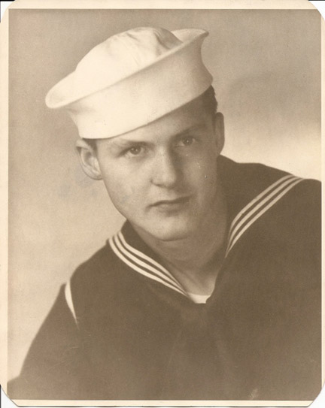
Master Sergeant Olen B. McLaughlin
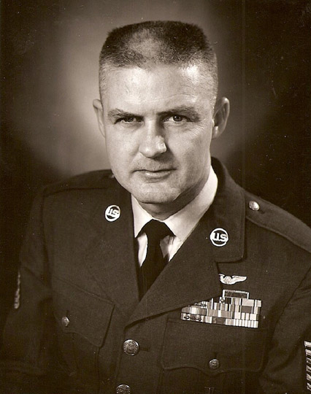
Jay County's only missing serviceman. Missing in Action over the South China Sea, 7 July 1967. Olen Burke McLaughlin was born on Christmas Eve 1927 to Ray Burke McLaughlin and Hattie Honora Hannon in Jay County. He had four brothers; Keith, Ed, Richard, and Glen. Keith, Dick and Olen all joined the navy, Olen joining in 1945 right near the end of WW2. Olen served two years as a signalman in the navy, got out, and went into the Air Force which was a new branch of the military that had just separated from the army.
Olen was married first for a brief period, and later married Marjorie who had two daughters (Cynthia and Brenda) that Olen treated as his own. Olen’s family in Portland didn’t see him much after he enlisted. He would return home on leave every few years for family gatherings, but he was stationed all over the country including Maine and Mississippi. During his air force career, he spent time in radio maintenance, and working on missiles before becoming a tail gunner on a B52 bomber. Olen was stationed with the 454th Bombardment Wing, Colombus AFB, Mississippi. On orders from President Johnson, B-52s had begun striking targets in North Vietnam on 11 Apr 1966, and the initial attack against the Mu Gia Pass marked the largest single bomber raid since World War II. Olen told his family that he could be deployed to Vietnam at a moments notice. Unknown to his family, this was about to happen as Olen and his crew were reassigned to the 4133rd Bomber Wing, Anderson AFB, Guam, in June 1967.
On 7 July 1967, B52D (SN # 56-0595) radio call sign Red 2, along with other aircraft from the 4133rd Bomb Wing were sent on a mission to bomb North Vietnam. The crew of Red 2 was Pilot CPT George Westbrook; Copilot CPT Harold Dean Thompson; Navigator 1LT George Emerson Jones; Radar Navigator CPT Charles H. Blankenship; Electronic Warfare Officer CPT Toki R. Endo; Rear Gunner MSGT Olen McLaughlin. The flight was approaching the initial point for the turn toward the target when the lead aircraft, Red 1, experienced an equipment malfunction. While changing formation lead, Red 2 had a mid-air collision with Red 1 (B52D SN # 56-0627) over the South China Sea near Saigon. The aircraft were approximately 20 miles offshore at the point of Vinh Binh Province when the accident occurred. Seven crewmembers from both aircraft were rescued, but six were not. On Red 2, CPT Blankenship, 1LT Jones, and MSGT McLaughlin were killed. Major General William J. Crumm, commander of the 3rd Air Division, was aboard Red 1 and became the highest ranked casualty of the Vietnam War.
Because Olen’s body has never been recovered, he is still officially listed as Missing In Action. He has a memorial headstone at Arlington National Cemetery. Cora Mae (Cheeseman), Dick’s widow, was kind enough to loan us a 12” x 14” official portrait of Olen in his air force dress uniform.
Courtesy of Museum of the Soldier

