DONALD LYNN VALENTINE

is honored on Panel 6W, Line 58 of the Vietnam Veterans Memorial.
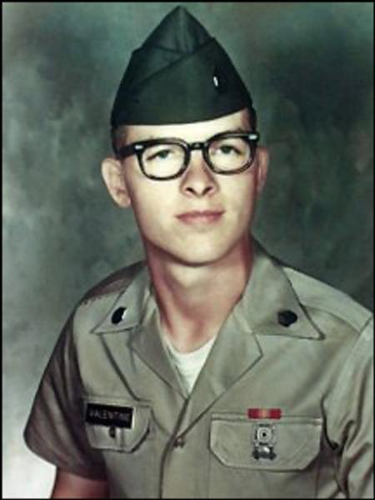
- Wall Name: DONALD L VALENTINE
- Date of Birth: 12/2/1946
- Date of Casualty: 11/13/1970
- Home of Record: LAFAYETTE
- County of Record: TIPPECANOE COUNTY
- State: IN
- Branch of Service: ARMY
- Rank: SGT
- Panel/Line: 6W, 58
- Casualty Province: THUA THIEN
http://www.vvmf.org/Wall-of-Faces/53200/DONALD-L-VALENTINE

