Viola (Baumgartner) Drayer
December 27, 1896 – April 2, 1966

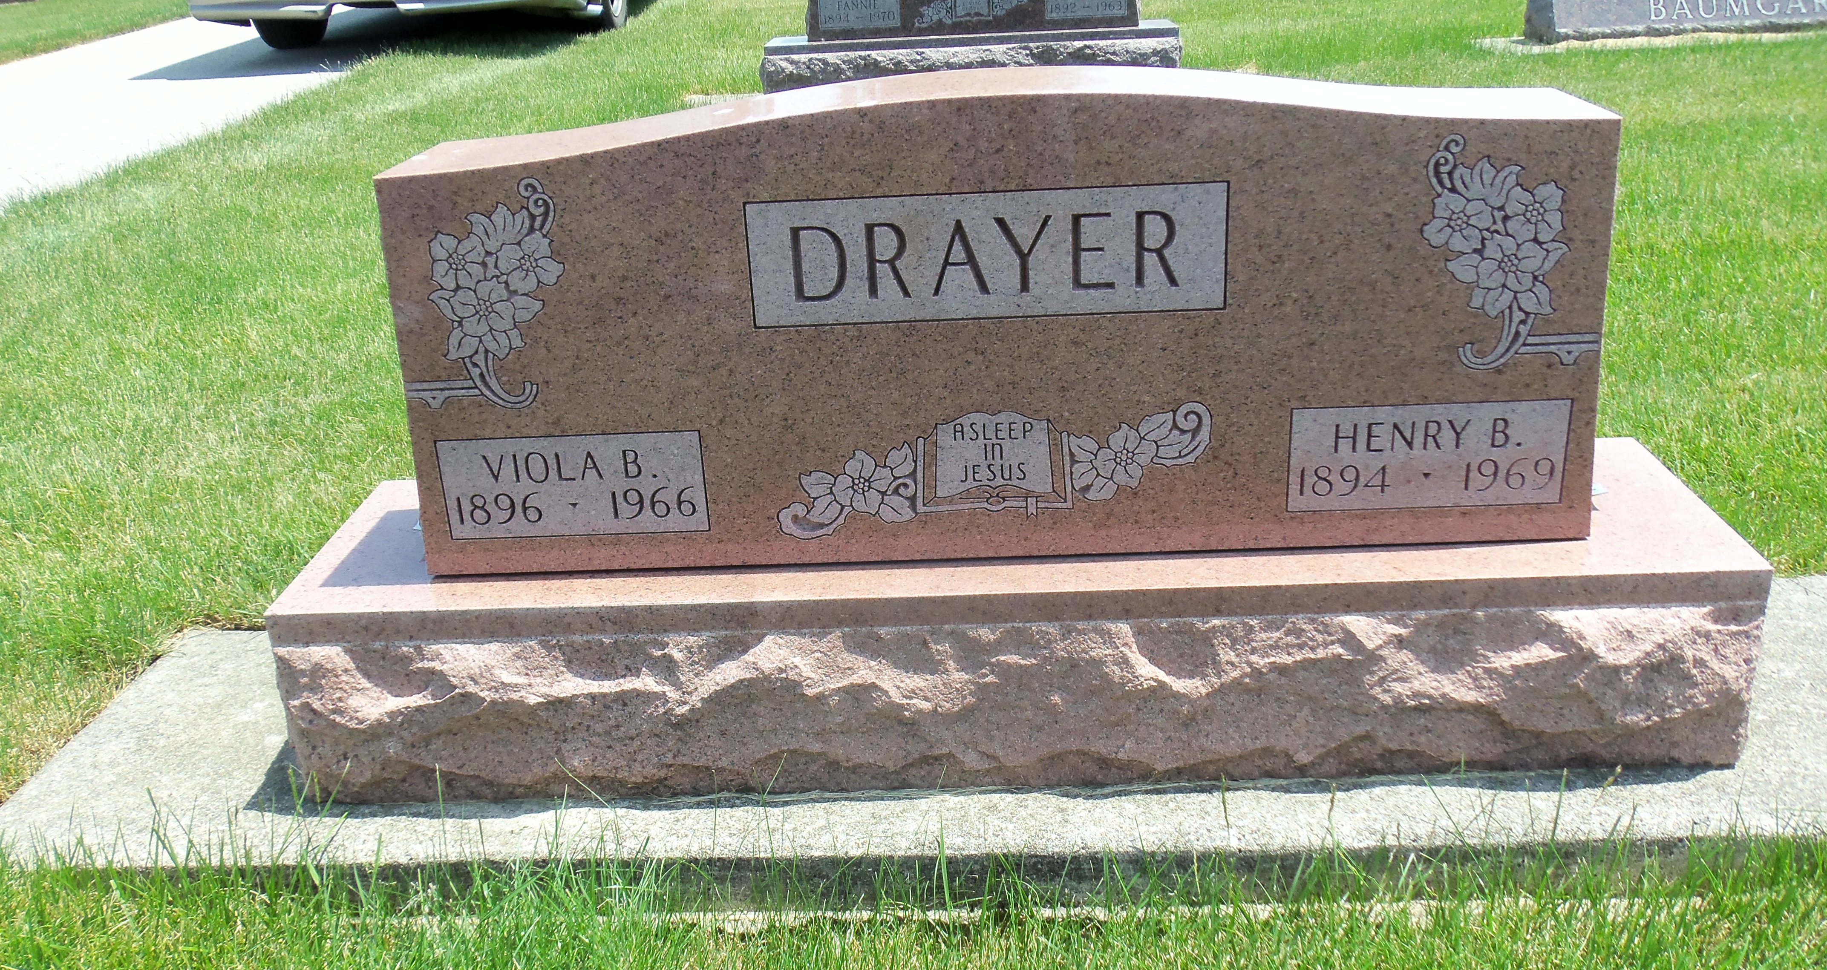
Photo by Danielle Brooks

Wells County's First 1966 Fatality
Adams County Woman Killed in Crash Here; 3 are Hurt
An Adams County woman was killed and three other persons injured at 8 p.m. Saturday in a near head-on crash on South Main St., almost directly in front of Ludwig's Market. Dead on arrival at Clinic Hospital was Mrs. Viola Drayer, 69, of Decatur Route 4. Coroner Robert Haggard set the cause of death as severe head injuries and internal injuries. Her death marked the first traffic fatality of the year for both Wells County and Bluffton.
Henry B. Drayer, 71, Mrs. Drayer's husband, was admitted to the hospital with facial lacerations. He is listed in satisfactory condition.
The occupants of the second car, Michael Gerwig, 18, son of Mr. and Mrs. Paul Gerwig, 217 North Bond St., and David M. Steffen, 17, son of Mr. and Mrs. Raymond Steffen, 205 North Union St., are in the Clinic Hospital with multiple injuries.
Steffen suffered a fractured jaw and severe facial lacerations. His condition is fair.
Gerwig, the driver of the car, had a mild concussion, lacerations and abrasions. He is in satisfactory condition.
Police said that the Drayer car was southbound when Drayer turned at Ludwig's into the path of the northbound Gerwig machine. The impact spun both vehicles in a half-circle. The Drayer auto came to rest in the driveway of the Dutch Maid car wash. The Gerwig car stopped in the middle of the roadway. The Drayer auto, a 1957 Buick, and the Gerwig vehicle, a 1965 Chevrolet, were demolished.
Police said Saturday evening drivers flocked to the scene and seriously impeded emergency vehicles attempting to get to the accident.
Mrs. Drayer was born Dec. 27, 1896, a daughter of Samuel and Elizabeth Tonner Baumgartner. Her marriage to Mr. Drayer took place Feb. 22, 1915 in Vera Cruz.
She lived in Adams County most of her life and was a member of the Apostolic Christian Church.
Surviving, in addition to the husband, are one foster daughter, Mrs. Jerry (Adella) Gerwig of Pontiac, Mich., and three sisters, Mrs. Chris (Rosina) Drayer of Bluffton, Mrs. Victor (Amelia) Sprunger of Monroe Route 1 and Mrs. Henry (Nova) Isch of Berne.
Friends may call after 7 p.m. today at the Goodwin Funeral Home. The body will be taken at noon Wednesday to the Apostolic Christian Church to lie in state until services at 1:30 p.m. Rev. Orville Ringger will officiate. Burial will be in the church cemetery.

Bluffton News-Banner, Wells County, IN; Monday, April 4, 1966

