Homer H. Fiechter
February 25, 1921 – March 3, 2008
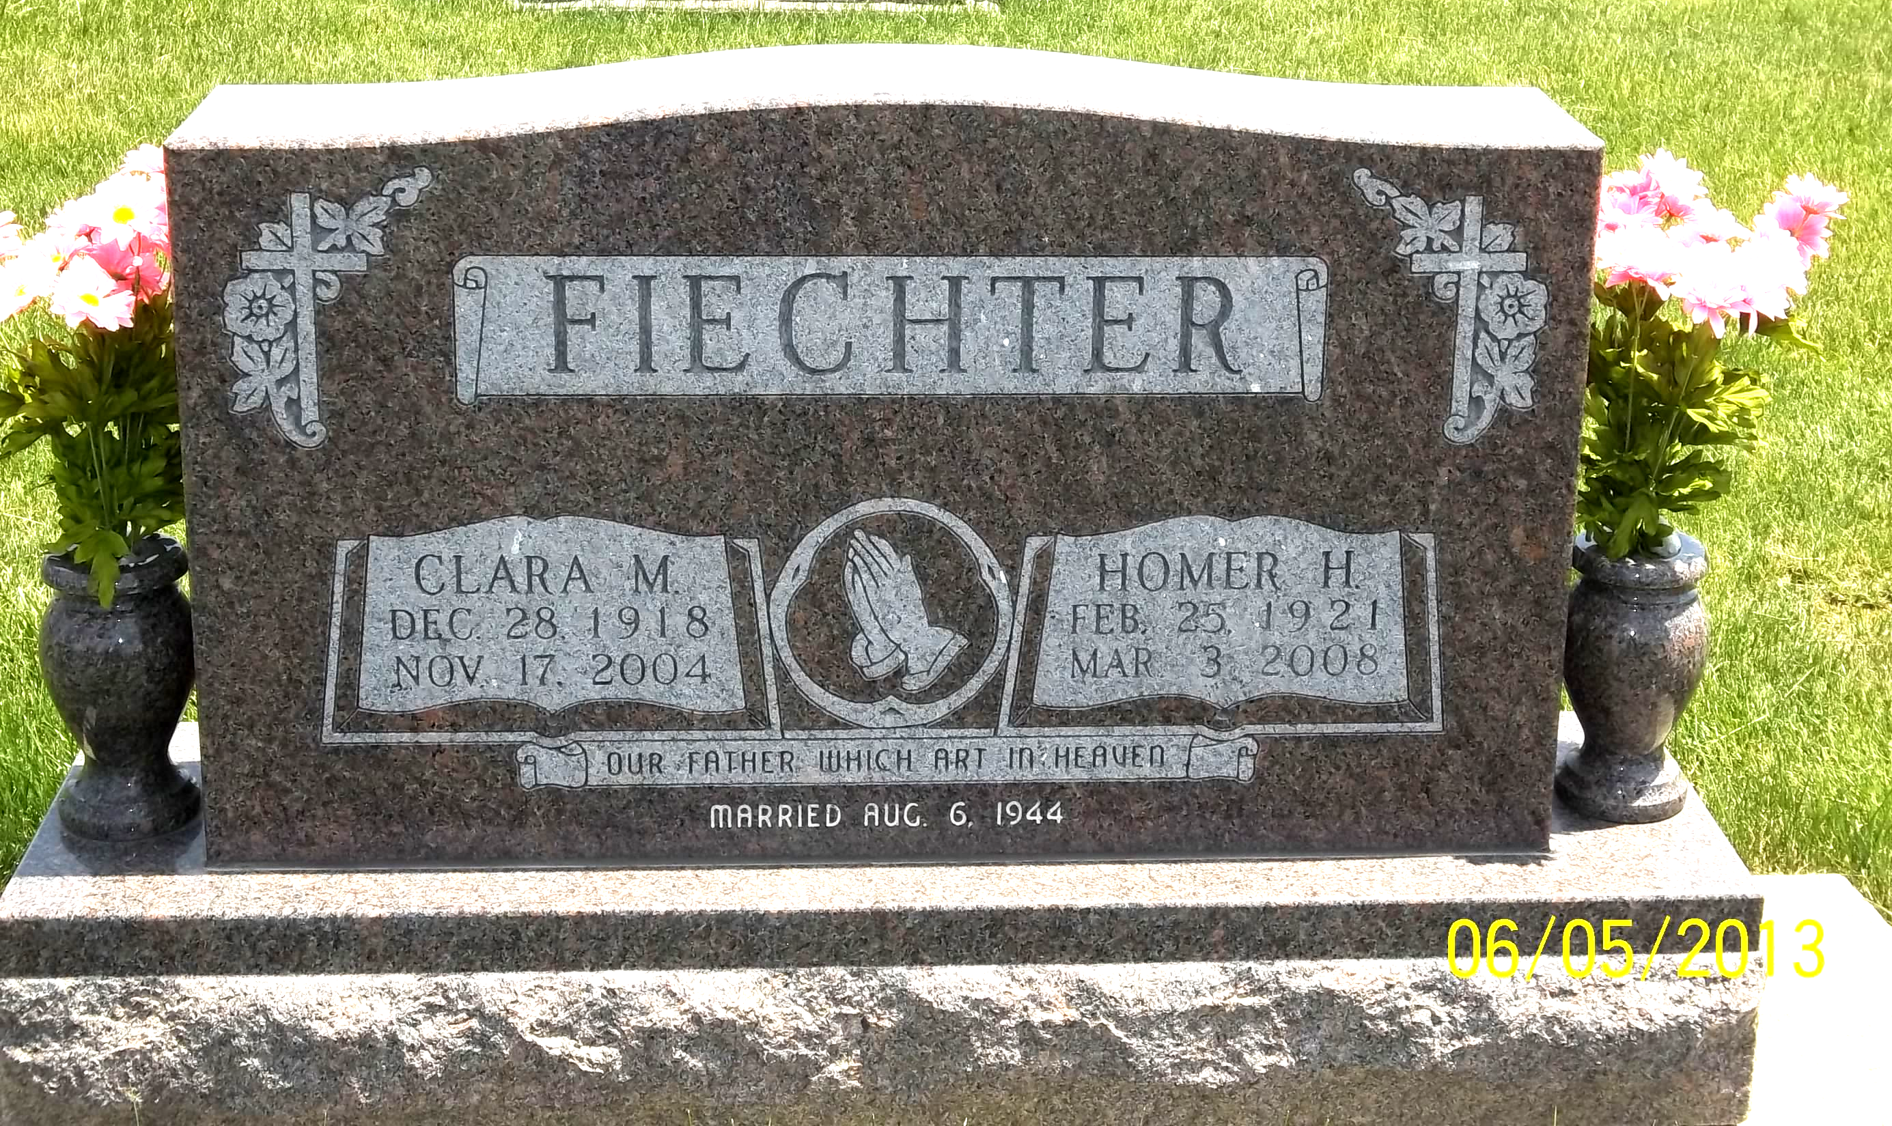
Photo by Danielle Brooks
Homer H. Fiechter, 87, of Craigville, died at 10:28 p.m. Monday, March 3, 2008, at Bluffton Regional Medical Center.
Born in Wells County on Feb. 25, 1921 to Joel and Lucinda (Baumgartner) Fiechter, he married Clara M. Schladenhauffen in Bluffton on Aug. 6, 1944; she preceded him in death on Nov. 17, 2004.
Mr. Fiechter was a lifelong farmer in Wells County, and a member of the Apostolic Christian Church.
Surviving relatives include two sons, Ray (Carol) Fiechter of Noblesville and Kent (Deb) Fiechter of Pendleton; one daughter, Sheryl (Alan) Ringger of Bluffton; three brothers, Alvin (Bernice) Fiechter, Melvin (Doris) Fiechter and Wayne (Dorothy) Fiechter, all of Bluffton; two sisters, Gladys Maller and Justine (Donald) Gerber, both of Bluffton; nine grandchildren and 25 great-grandchildren.
Mr. Fiechter was also preceded in death by two sisters, Devona Gerber and Ellen Stoller, and one brother, Raymond Fiechter.
Funeral services will be at 10:30 a.m. Saturday, at the Apostolic Christian Church East, with Ed Schwartz and Ron Kipfer officiating. Calling hours will be from 6 to 8 p.m. Thursday and from 1 p.m. to 8 p.m. Friday at the Goodwin Memorial Chapel in Bluffton and from one hour prior to the service at the church. Burial is at Apostolic Christian Cemetery.

Bluffton News-Banner, Wells County, IN; Wednesday, March 5, 2008

