Pauline D. (Kipfer) Fiechter
October 28, 1923 – December 12, 2005
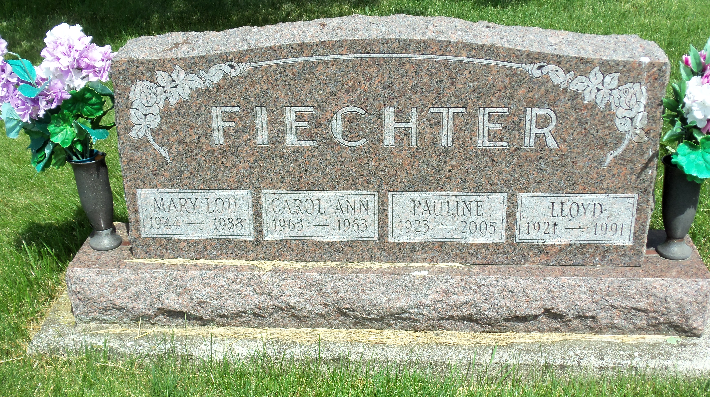
Photo by Danielle Brooks
Pauline D. Fiechter, 82, of Bluffton died at 7 p.m. Monday, Dec. 12, 2005, at River Terrace Estates.
Mrs. Fiechter worked 20 years in the snack bar at the Bowling Center. She also worked for the former Vera Cruz Opportunity Center, at the Franklin Electric Canteen and as a custodian for Dr. Trubey's office. She was a member of the First Church of Christ.
Born Oct. 28, 1923, in Wells County to David and Fannie Reinhard Kipfer, her marriage on Sept. 4, 1943, in Bluffton was to Lloyd W. Fiechter, who preceded her in death on Oct. 4, 1991.
Survivors include two sons, Terry Fiechter of Bluffton and Tom Fiechter of Fort Wayne; two brothers, Arthur and Donald Kipfer, both of Bluffton; seven grandchildren; and four great-grandchildren.
She was preceded in death by two daughters, Mary Lou Fiechter and Carol Ann Fiechter.
Calling is from 2 to 8 p.m. Wednesday at Goodwin Memorial Chapel.
Services are at 10:30 a.m. Thursday at the funeral home with Rev. Larry Sprinkle officiating. Burial will be in Apostolic Christian Cemetery.
Preferred memorials are to Bi-County Services or the Heart Association.

Bluffton News-Banner, Wells County, IN; Tuesday, Dec. 13, 2005

